Quantitative Analysis of Short-Term Price Prediction in BTCUSDT Perpetual Futures

0.Abstract
This study examines whether extreme bid/ask delta contains predictive information about subsequent short-term price movements in the Binance BTCUSDT USDT-margined perpetual futures market. Historical aggregate trade data were classified as buyer- or seller-initiated and aggregated into one-minute and five-minute intervals. Raw and normalised delta events were identified using the 5th and 95th percentiles, with the 1st and 99th percentiles representing very strong conditions. Subsequent returns were measured over 1-, 5-, 15-, 30- and 60-minute horizons using descriptive statistics, correlation analysis and one-sample t-tests.
The results provided greater support for short-term reversal than for continuation, particularly when an extreme negative raw delta was followed by positive returns. However, Pearson and Spearman correlations were consistently small, and normalising delta generally weakened the observed relationship. Although several individual conditions were statistically significant, the effects were not consistent across delta measures, timeframes and return horizons. Furthermore, a simplified economic assessment showed that the returns were insufficient to overcome the assumed 0.2% round-trip transaction cost. Conditioning events on VWAP and cumulative volume delta also failed to produce a consistently stronger relationship.
Overall, bid/ask delta provides useful information about aggressive trading activity but has limited value as a standalone predictor of future returns. The findings demonstrate the importance of distinguishing statistical significance from economic viability and accounting for market context and trading costs when evaluating order-flow signals.

1. Introduction
Financial markets operate as continuous auctions in which participants compete to buy and sell assets. In electronic markets, limit orders are organised within an order book, with bids representing available buying interest and offers representing available selling interest. Some participants provide liquidity by submitting limit orders and waiting for execution, while others demand liquidity by trading immediately against existing orders. Aggressive buyers lift available offers, whereas aggressive sellers hit available bids.
This distinction is important because every completed trade necessarily contains both a buyer and a seller. It is therefore misleading to describe price changes as being caused simply by there being “more buyers than sellers”. The quantity bought must equal the quantity sold. What differs is which participant demanded immediate execution. A buyer-initiated trade occurs when a buyer accepts a passive seller’s offer, while a seller-initiated trade occurs when a seller accepts a passive buyer’s bid. Identifying the initiating side provides information about market participants' urgency that cannot be inferred from total trading volume alone.
This interaction can help explain why prices move. If aggressive buyers repeatedly execute against the available offers, liquidity at the current price may eventually be consumed. Buyers who continue to demand immediate execution must trade against offers at higher prices, resulting in an upward move in the market. The opposite process can occur when aggressive sellers repeatedly execute against resting bids. If available buying liquidity is consumed, subsequent sellers must accept progressively lower prices. From this perspective, short-term price movements are influenced not simply by the presence of buyers and sellers, but by the interaction between participants' urgency to obtain liquidity and the amount of passive liquidity available to absorb their orders.
When aggressive buyers repeatedly consume available offers, they may exhaust the liquidity available at the current price and be forced to transact at progressively higher prices. Similarly, persistent aggressive selling can remove resting bids and move the market lower. However, aggressive order flow does not determine price movement independently. Its effect depends on the quantity and resilience of passive liquidity available on the opposite side of the order book. A large buy order may move price substantially when sell-side liquidity is limited but have little effect when passive sellers are willing to absorb it.
Bid/ask delta is used to measure this imbalance:
Delta of interval = interval x (buy volume) – (sell volume)
Where buy volume represents the amount x transacted against the offers, and Sell volume represents seller-initiated volume against the bids during a selected interval or at a price level.
A positive delta indicates that buyer-initiated volume exceeded seller-initiated volume during the interval, while a negative delta indicates greater seller-initiated volume. An extreme positive or negative delta therefore identifies a period of unusually one-sided demand for liquidity.
However, delta is partly influenced by the total volume traded during an interval. A large raw delta may occur because trading activity was unusually high rather than because one side was exceptionally dominant. For this reason, the study examines both raw delta and normalised delta. Normalised delta expresses the imbalance relative to total traded volume, allowing the direction and proportional strength of aggressive activity to be compared across periods with different levels of market participation.
There are two competing outcomes that may follow an extreme delta event. First, aggressive pressure remains persistent, and price continues to move in the direction of the imbalance. A strong positive delta would therefore precede positive returns, while a strong negative delta would precede negative returns. Alternatively, extreme aggression may be absorbed by passive liquidity. If substantial buying fails to generate further upward movement, this may indicate that passive sellers are strong enough to meet demand. Once aggressive buying weakens, price may reverse. Extreme delta can therefore represent either sustained pressure or exhaustion, depending on the surrounding liquidity conditions.
This distinction is central to the present research. A positive relationship between delta and price over the same period does not necessarily indicate that delta has predictive value. If buyers aggressively consume offers, it is reasonable to expect that prices may rise while that buying is taking place. The question this research aims to answer is whether the information contained in that imbalance remains relevant after the measurement period has ended.
The study therefore distinguishes between the simultaneous price impact of order flow and its relationship to subsequent price movement. Rather than asking whether strong buying pressure accompanies rising prices, the research examines whether observing an unusually large imbalance in aggressive buying or selling provides information about the price's next move.

2. Research Objectives and Approach
This study uses Binance BTCUSDT USDT-margined perpetual futures to investigate the relationship between bid/ask delta and subsequent price movements. Bitcoin provides a useful setting for high-frequency order-flow analysis because cryptocurrency markets trade continuously, generating numerous transactions within varying market conditions.
The use of Leverage means that order flow in the perpetual market may reflect discretionary trading, hedging and forced liquidation activity. These features can produce concentrated aggressive buying or selling, making the contract relevant for examining short-term order-flow imbalances. Binance is also the chosen exchange as its perpetual futures market has the highest trading volume (Tools, 2026).
Transaction records from the Binance BTCUSDT perpetual market are classified as buyer- or seller-initiated using the buyer–taker information attached to each trade. These observations are aggregated into one-minute and five-minute candles, from which aggressive buy volume, aggressive sell volume, raw delta and normalised delta are calculated. Strong and very strong delta events are identified using the 5th and 95th percentiles and the more extreme 1st and 99th percentiles of their respective distributions.
Subsequent returns are then measured over 1-, 5-, 15-, 30- and 60-minute horizons. The analysis compares the mean, median, variability and proportion of positive returns following each delta condition. Pearson and Spearman correlations are used to assess the broader relationship between delta and forward returns, while hypothesis tests examine whether the returns following extreme observations are statistically distinguishable from zero. A simplified economic assessment also considers whether statistically significant effects remain viable after entry and exit fees.
Finally, robustness tests examine whether the relationship changes when delta events are conditioned on additional market context. Daily volume-weighted average price is used to distinguish whether price is trading above or below its volume-weighted reference level, while cumulative volume delta, reset over seven-day periods, represents the broader accumulation of aggressive buying and selling pressure.
The central question this study will be based around is therefore:
Does extreme bid/ask delta in the Binance BTCUSDT perpetual futures market contain information about subsequent short-term price movements?
The hypotheses are:
H₀: Extreme bid/ask delta has no statistically significant relationship with subsequent price movements.
H₁: Extreme bid/ask delta has a statistically significant relationship with subsequent price movements
The alternative hypothesis is intentionally non-directional because both continuation and reversal are theoretically plausible. The direction, magnitude and economic relevance of the relationship are therefore determined from the empirical evidence rather than assumed in advance.

3. Literature / Theoretical Framework

3.1 Market Microstructure and Price Formation
Market microstructure examines how trading mechanisms, order submission, and liquidity influence the process through which prices are formed. In an electronic limit order book, prices emerge from the interaction between participants demanding immediate execution and those willing to provide liquidity through resting orders.
A practical way to view this process is through the lens of market auction theory. Buyers compete for available offers, while sellers compete for available bids. When aggressive buying repeatedly removes available sell-side liquidity, transactions may be forced to occur at progressively higher prices. The reverse can occur when aggressive sellers consume available bids. Short-term price formation can therefore depend not only on the direction of trading interest, but also on the amount of liquidity available to absorb it.
Formal market microstructure theory provides an important explanation for why order flow may contain information. Kyle (1985) developed a model in which an informed trader gradually trades against less-informed market participants, while a market maker adjusts prices in response to observed aggregate order flow. One of the central implications of the model is that order flow can transmit private information into prices, with the parameter commonly referred to as Kyle's lambda representing the price impact associated with trading activity.
This provides an important theoretical basis for the present study. If some aggressive trades reflect information or expectations not yet fully incorporated into price, unusually strong order flow may contain information about subsequent price movements rather than simply recording transactions that have already occurred.
At the same time, order flow does not need to originate entirely from informed traders. Market orders may also result from hedging, portfolio adjustment, execution requirements, liquidations, or other liquidity needs. Consequently, a large imbalance does not determine directly why the trades occurred. The empirical question is therefore whether the imbalance itself contains measurable information about what price does afterwards.

3.2 Order Flow Imbalance and Price Impact
Bid/ask delta can be considered a form of trade-flow imbalance, measuring the difference between aggressive buyer-initiated and seller-initiated volume:
Delta = (Buy volume – sell volume) over the interval
A positive value indicates that aggressive buyers accounted for more executed volume during the interval, while a negative value indicates greater aggressive selling.
Existing empirical research provides strong evidence that imbalances in order flow are related to short-term price changes. Cont et al(2014) examined high-frequency order-book data for 50 U.S. equities and found an approximately linear relationship between order-flow imbalance and short-term price changes. Importantly, they also found that the strength of price impact was inversely related to available market depth: the same imbalance produced a larger price response in a thinner market than in a deeper one.
This result is particularly relevant to the present research because it demonstrates that the effect of buying or selling pressure cannot be considered independently of available liquidity. A large positive delta may produce substantial upward movement when offers are limited, while a similar delta may produce little movement when substantial sell-side liquidity is available.
The distinction between trade-flow delta and broader order-book imbalance is also important. Bid/ask delta measures executed aggressive trading, whereas order-book depth captures changes in resting bids and offers, cancellations, and new limit orders. Cont et al.'s (2014) measure therefore captures a broader range of order-book events than the executed-trade delta, which is used as the primary variable in this study. Nevertheless, both measures are based on the same underlying idea: short-term price formation depends on an imbalance between buying and selling pressure relative to available liquidity.

3.3 Simultaneous Price Impact Versus Predictive Information
A key issue in the existing literature is the distinction between explaining a price movement that occurs concurrently with a strong Delta and predicting a price movement that occurs afterwards.
A contemporaneous relationship can be represented as:
Delta over the interval => change in price from the start of the interval
Such a relationship is economically intuitive. If aggressive buyers withdraw their offers, the price may rise during the same interval. However, this does not necessarily mean that the Delta provides information about future returns.
The relationship of primary interest in this study is instead:
Delta over interval => Return over subsequent time intervals
This distinction is important because having strong current explanatory power does not necessarily mean it has predictive power. A measure could explain why the price moved during a particular minute without providing any information about what happens in the following minute.
More recent research has begun to examine this issue directly in cryptocurrency markets. Anastasopoulos et al. (2026) study order flow across cryptocurrencies and report that aggregate order flow has both explanatory and predictive power for cryptocurrency returns. Their results suggest that order-flow information can contain information beyond its contemporaneous relationship with price and can contribute to out-of-sample return forecasting.
This finding is particularly important for the present project because it supports the broader proposition that cryptocurrency order flow may contain forward-looking information. However, their research considers aggregate cryptocurrency order flow and return prediction at broader horizons, whereas the present study focuses specifically on extreme executed bid/ask delta in BTCUSDT perpetual futures and subsequent short-horizon price movement.

3.4 Order-Flow Persistence
One possible explanation for predictive order flow is persistence.
Large institutional or algorithmic orders are not always executed as a single transaction. A participant seeking to acquire or sell a significant quantity may divide the position into a sequence of smaller orders to reduce immediate market impact. As a result, a period of aggressive buying may be followed by further aggressive buying rather than an immediate return to a balanced state.
Under this interpretation, an extremely positive delta may indicate the presence of sustained buying pressure that has not yet fully materialised. If additional aggressive buying follows, available sell-side liquidity may continue to be consumed, and prices may continue to rise. Similarly, a strong negative delta may precede further selling pressure.

3.5 Liquidity and absorption
Persistent order flow is not the only possible outcome. The effect of aggressive trading depends heavily on the passive liquidity available to absorb it.
Cont et al. (2014) show that the same delta can have different price effects depending on market depth, with deeper markets exhibiting a smaller price response to a given imbalance. This supports the practical observation that aggressive buying does not necessarily lead to a large upward price move.
This difference is known as absorption -- the process by which aggressive market orders produce relatively limited price impact because sufficient liquidity is available on the opposite side of the market.
If extremely aggressive buying fails to produce meaningful upward price movement, it may indicate that passive sellers can satisfy the incoming demand. If the aggressive buying subsequently weakens, the market could become vulnerable to reversal. The same logic applies to aggressive selling absorbed by strong bid-side liquidity.
This gives rise to a competing reversal hypothesis:
Extreme delta + weak price response = possible subsequent reversal
This is important because it means that the predictive information contained within delta may depend not only on its magnitude but also on the price response relative to that magnitude.

3.6 Bitcoin Market Microstructure
Bitcoin provides a useful setting for examining these mechanisms because price formation is distributed across multiple interconnected spot and derivatives markets.
Research examining Bitcoin market structure has found that order-flow information can contribute to price formation across exchanges. Albers et al. analyse fragmentation and cross-impact in Bitcoin markets and apply order-flow imbalance measures to investigate how activity on one trading venue can influence price formation elsewhere.
This division is important for the present study. Unlike a centralised futures exchange with a single consolidated order book, Bitcoin trading occurs simultaneously across many venues. The bid/ask delta calculated on Binance therefore reflects the balance of aggressive trading in that market rather than a complete measure of global Bitcoin demand.
At the same time, previous research suggests that cryptocurrency derivatives can play an important role in price discovery. Kapar and Olmo (2019), using Bitcoin spot and futures prices from the early CME/CBOE futures period, found that the futures market contributed more to price discovery than the spot market in their sample.
Fassas, Papadamou and Koulis (2020) similarly report evidence that Bitcoin futures played an important role in incorporating new information, despite substantially greater trading volume in the decentralised spot market during their sample.
Research examining cryptocurrency-native derivatives markets provides further evidence. Alexander et al. (2020) find that perpetual swaps and futures traded on major cryptocurrency exchanges were important contributors to Bitcoin price discovery.
More specifically, Alexander et al. (2020) examine high-frequency Bitcoin markets and report that the Binance tether-margined perpetual contract was a major source of volatility transmission across the instruments in their sample.
This evidence supports the decision to examine Binance BTCUSDT perpetual futures rather than treating derivatives trading as merely secondary to the spot market.

3.7 Leverage, Liquidation and Extreme Order Flow
Perpetual futures introduce another mechanism that may be relevant when interpreting extreme delta: leverage and forced liquidation.
Participants in perpetual futures markets can take positions larger than their posted collateral. If the market moves sufficiently against a leveraged position, the position may be forcibly closed.
Liquidation orders can therefore generate aggressive trading that is not purely discretionary. For example, the liquidation of leveraged long positions can trigger forced selling into the market, while the liquidation of short positions can trigger forced buying.
Empirical research on Bitcoin perpetual futures provides evidence that forced liquidations can be economically significant. Cheng et al. (2021), studying BitMEX perpetual Bitcoin futures, document substantial liquidation activity and report very high leverage among liquidated positions in their sample.
This mechanism is particularly relevant to extreme delta. A large negative delta may reflect:
- long liquidations
- Aggressive selling
- Shorts being closed
Likewise, rising prices may trigger short liquidations, which contribute to further aggressive buying.
The present study does not initially attempt to classify each extreme delta event as resulting from discretionary trading or forced liquidation. However, leverage and liquidation provide an important theoretical mechanism through which unusually large order-flow imbalances may arise in perpetual futures markets.

4. Data

4.1 Data Source and Contract Selection
The study examines the Binance BTCUSDT USDT-margined perpetual futures contract. Bitcoin is the underlying asset, while USDT is used as the quote and margin asset. Unlike conventional futures, the contract does not have a fixed expiry date. This allows a continuous dataset to be constructed without combining contracts with different dates or accounting for price changes associated with contract rolls.
BTCUSDT was selected because its high trading activity produces a sufficiently dense sequence of transactions to measure aggressive buying and selling over short intervals. This is particularly important for the one-minute analysis, where limited trading activity could cause individual transactions to dominate the calculated imbalance. The use of a single contract and trading venue also ensures that all trades are classified under the same market rules and data structure.
Historical aggregate-trade records were obtained from Binance’s public USDⓈ-M Futures data archive and processed using Python. Each record contained an aggregate trade identifier, execution price, quantity, the first and final underlying trade identifiers, an exchange timestamp, an indicator showing whether the buyer was the market maker, and a best-price-match indicator.
Binance aggregate-trade records may combine executions associated with the same taker order at the same price. Consequently, the recorded event count should not be interpreted as the exact number of individual executions. However, the total executed quantity and the buyer-maker classification are retained, meaning the data remain suitable for measuring aggressive buy and sell volume over each interval.
The Final dataset covered the period from 2025/06/08 to 2026/07/08, with all timestamps converted into UTC.

4.2 Data Cleaning and Quality control
Before aggregation, the raw trade files were combined and checked for missing, duplicated or invalid observations. Aggregate trade identifiers were used to identify duplicate records, while price and quantity fields were converted to numeric formats. Observations containing missing values, non-positive prices or non-positive quantities were removed because they could not represent valid market transactions.
Trades were ordered using the Binance exchange timestamp rather than their position within the original files. Timestamp continuity and trade-identifier sequences were also examined to identify interruptions or incomplete sections of the sample. Where incomplete data were detected, the affected observations were excluded to avoid treating periods of missing activity as genuine low-volume intervals.
Extreme transaction sizes were not removed solely because they appeared unusual. Large trades and extreme delta observations are directly relevant to the research question and may represent genuine periods of concentrated market activity. An observation was therefore excluded only when there was evidence that it resulted from a data or recording error.

The test showed no duplicates, missing values, or gaps in time. This isn’t surprising as the data was sourced from the official Binance Database.

4.3 Bar Aggregation
Following cleaning, the aggregate trades were grouped into fixed, non-overlapping one-minute and five-minute intervals using their Binance timestamps. Both datasets were constructed directly from the same cleaned records, rather than by producing five-minute observations from previously aggregated one-minute candles.
For each interval, the first, highest, lowest and final execution prices formed the open, high, low and close. Total volume was calculated as the sum of the executed quantities within the interval and was expressed in BTC.
Aggressive buy and sell volumes were identified using the buyer-maker indicator. If the buyer was not the maker, the buyer demanded immediate execution from a passive seller and the quantity was classified as aggressive buy volume. If the buyer was the maker, the seller initiated the transaction against a passive buyer, and the quantity was classified as aggressive sell volume
A positive value indicates that aggressive buying exceeded aggressive selling, while a negative value indicates that aggressive selling was greater.
Raw delta is sensitive to changes in overall trading activity. For example, a 10 BTC imbalance represents a much larger proportional difference when total volume is 20 BTC than when it is 500 BTC. A normalised measure was therefore constructed:
Normalised delta = (delta/volume) x 100
Normalised delta ranges from −100% to +100%. Values approaching +100% indicate that nearly all volume was buyer-initiated, while values approaching −100% indicate that nearly all volume was seller-initiated. Raw delta measures the absolute size of the imbalance, whereas normalised delta measures the dominance of one side relative to total activity. Both measures were retained in the empirical analysis.

4.4 Descriptive Statistics
condition | minutes forward | events | average movement(%) | median movement(%) | standard deviation (%) | Positive movements (%)
strong buy delta | 1 | 28440 | -0.001650 | -0.004121 | 0.1045 | 46.96
strong buy delta | 5 | 28440 | -0.004762 | -0.009101 | 0.2078 | 46.78
strong buy delta | 15 | 28440 | -0.005494 | -0.011414 | 0.3465 | 47.68
strong buy delta | 30 | 28439 | -0.006859 | -0.012087 | 0.4595 | 48.28
strong buy delta | 60 | 28440 | -0.007566 | -0.013711 | 0.6279 | 48.57
very strong buy delta | 1 | 5688 | -0.002772 | -0.006448 | 0.1403 | 46.54
very strong buy delta | 5 | 5688 | -0.006734 | -0.014508 | 0.2498 | 46.11
very strong buy delta | 15 | 5688 | -0.010787 | -0.023815 | 0.4280 | 46.11
very strong buy delta | 30 | 5688 | -0.005248 | -0.024566 | 0.5436 | 47.35
very strong buy delta | 60 | 5688 | 0.005250 | -0.024765 | 0.7282 | 47.80
strong sell delta | 1 | 28439 | 0.001981 | 0.003138 | 0.1044 | 52.11
strong sell delta | 5 | 28438 | 0.003834 | 0.007553 | 0.2276 | 52.43
strong sell delta | 15 | 28438 | 0.005974 | 0.012553 | 0.3597 | 52.45
strong sell delta | 30 | 28440 | 0.008825 | 0.016131 | 0.4974 | 52.31
strong sell delta | 60 | 28438 | 0.011242 | 0.021116 | 0.6432 | 52.15
very strong sell delta | 1 | 5687 | 0.004649 | 0.006211 | 0.1527 | 52.63
very strong sell delta | 5 | 5687 | 0.009297 | 0.017488 | 0.3326 | 54.11
very strong sell delta | 15 | 5687 | 0.017010 | 0.032772 | 0.4827 | 55.07
very strong sell delta | 30 | 5688 | 0.022979 | 0.037370 | 0.6490 | 53.99
very strong sell delta | 60 | 5688 | 0.036867 | 0.038872 | 0.7705 | 53.38
strong normalised buy delta | 1 | 28440 | 0.000867 | 0.000000 | 0.0394 | 48.08
strong normalised buy delta | 5 | 28440 | 0.000748 | -0.000349 | 0.0866 | 49.25
strong normalised buy delta | 15 | 28439 | 0.000615 | -0.001545 | 0.1486 | 49.31
strong normalised buy delta | 30 | 28437 | -0.000756 | -0.000248 | 0.2135 | 49.89
strong normalised buy delta | 60 | 28440 | -0.001867 | -0.001680 | 0.3033 | 49.65
strong normalised sell delta | 1 | 28440 | -0.000213 | 0.000000 | 0.0397 | 48.20
strong normalised sell delta | 5 | 28440 | 0.000670 | 0.001539 | 0.0839 | 51.27
strong normalised sell delta | 15 | 28439 | 0.001247 | 0.001845 | 0.1436 | 50.67
strong normalised sell delta | 30 | 28438 | 0.001169 | 0.001618 | 0.2041 | 50.50
strong normalised sell delta | 60 | 28438 | 0.000423 | 0.002442 | 0.2960 | 50.56
very strong normalised buy delta | 1 | 5688 | 0.001775 | 0.000000 | 0.0320 | 49.07
very strong normalised buy delta | 5 | 5688 | 0.002078 | 0.000090 | 0.0697 | 50.14
very strong normalised buy delta | 15 | 5688 | 0.002313 | 0.000086 | 0.1179 | 50.02
very strong normalised buy delta | 30 | 5686 | 0.002844 | 0.003589 | 0.1679 | 51.14
very strong normalised buy delta | 60 | 5688 | 0.008097 | 0.002920 | 0.2454 | 50.95
very strong normalised sell delta | 1 | 5688 | -0.001104 | 0.000000 | 0.0302 | 45.31
very strong normalised sell delta | 5 | 5688 | 0.000356 | 0.001291 | 0.0663 | 51.42
very strong normalised sell delta | 15 | 5688 | 0.003128 | 0.002203 | 0.1141 | 50.97
very strong normalised sell delta | 30 | 5688 | 0.007087 | 0.005351 | 0.1601 | 51.74
very strong normalised sell delta | 60 | 5688 | 0.008887 | 0.005919 | 0.2300 | 51.58

5. Methodology
This section explains how extreme bid/ask delta events were identified and how their relationships with subsequent BTCUSDT returns were evaluated. The study used a quantitative event-study design covering raw and normalised delta measured over one-minute and five-minute intervals.

5.1 Research Design and Hypotheses
An event occurred when raw or normalised delta reached a specified extreme percentile of its distribution. Returns following these observations were measured to determine whether unusually one-sided aggressive trading was associated with continuation or reversal.
Events were identified only after the relevant one-minute or five-minute interval had closed. This is important because the complete delta value could not be known until all trades within the interval had occurred. Measuring returns from the closing price of the event interval prevented price movement during signal formation from being misclassified as a subsequent response.
The hypotheses are:
H₀: Extreme bid/ask delta has no statistically significant relationship with subsequent short-term price returns.
H₁: Extreme bid/ask delta has a statistically significant relationship with subsequent short-term price returns.
The alternative hypothesis was non-directional. Extreme order flow could lead to continuation if aggressive pressure persisted, or reversal if the aggressive activity was absorbed or became exhausted. The direction of the relationship was therefore determined from the empirical results.

5.2 Identification of Extreme Delta Events
Raw and normalised delta were tested separately. This allowed the analysis to distinguish between the absolute size of an order-flow imbalance and its size relative to total volume. The one-minute and five-minute distributions were also evaluated independently because the magnitude and variability of delta naturally change with the aggregation interval.
Four event categories were constructed for each delta measure:
Strong buy delta = Delta above the 95th percentile of observations.
Strong sell delta = Delta below the 5th percentile of observations
Very strong buy delta = Delta above the 99th percentile of observations
With delta representing either raw or normalised delta. The strong conditions captured the lowest and highest 5% of observations, while the very strong conditions captured the more restrictive lowest and highest 1%. Very strong events were therefore also contained within the broader strong-event samples.
Percentiles were calculated from the full analytical sample. This produced consistent definitions across the study and avoided imposing an arbitrary fixed BTC threshold. However, because the thresholds used information from the complete sample, they should be interpreted as retrospective event classifications rather than trading thresholds estimated in real time.

5.3 Measurement of Subsequent Price Movement
Subsequent price movement will be measured 1, 5, 15, 30 and 60 minutes after each extreme delta event. The same time horizons will be used for both the one-minute and five-minute delta samples, allowing their results to be compared directly.
The event price will be the closing price of the bar in which the extreme delta occurs. Forward return will measure the percentage change between this price and the market price at each future horizon.
For extreme positive delta, positive subsequent returns will indicate continuation, while negative returns will indicate reversal. For an extreme negative delta, subsequent negative returns will indicate continuation, and positive returns will indicate a reversal.
Examining several horizons will show whether the initial effect strengthens, weakens or changes direction over time. This is important because aggressive order flow may produce an immediate price movement before being absorbed or reversed at a later stage.

5.4 Statistical Testing
For every delta condition and forward horizon, the analysis reported the number of observations, mean return, median return, standard deviation and percentage of positive returns. These measures showed both the average response and the distribution of outcomes following extreme events.
Pearson correlation was used to measure the linear relationship between delta and forward returns across the full sample. Spearman rank correlation was also calculated to identify monotonic relationships that may not be linear and to reduce the influence of extreme numerical observations. Raw and normalised delta were analysed separately at each return horizon.
A two-sided one-sample t-test was then used to determine whether the mean forward return following each extreme condition differed significantly from zero:
$$\frac{\overline{R}}{s_{R}/\sqrt{n}}$$
Where R is the mean forward return, s_{R} is its sample standard deviation and n is the number of event observations. The analysis reported the estimated mean return, t-statistic, ordinary p-value and 95% confidence interval.
A 5% significance level was applied. The null hypothesis was rejected where the ordinary p-value was below 0.05. The sign of the mean return was then used to determine whether the statistically significant result indicated continuation or reversal.
The tests used ordinary, unadjusted p-values. No Newey–West correction or multiple-testing adjustment was applied in the final analysis. Consequently, statistical significance was interpreted alongside effect size, consistency across horizons and the economic test rather than being treated as sufficient evidence of predictability by itself. Overlapping forward-return periods and the large number of conditions tested are considered further in the study’s limitations.

5.5 Economic Significance
Statistical significance does not establish that a relationship can be traded profitably. An economic assessment was therefore conducted for the conditions that produced statistically significant results.
A hypothetical position was entered at the closing price of each qualifying event interval and exited at the price corresponding to the relevant forward horizon. The position direction reflected the observed relationship. For example, a negative-delta condition followed by positive returns was tested as a long reversal strategy, whereas a positive-delta condition followed by negative returns was tested as a short reversal strategy.
Gross strategy returns were calculated from the relevant forward return, with the sign reversed for short positions. A transaction fee of 0.1% was deducted at entry and a further 0.1% at exit, producing an assumed round-trip cost of 0.2% per trade
The analysis reported the number of trades, cumulative gross return, cumulative net return and number of profitable trades after fees. Slippage, bid–ask to spread and funding payments were not incorporated, meaning the exercise represents a simplified estimate of economic viability rather than a fully executable trading strategy. If the relationship failed after the stated fees, adding further trading costs could only weaken its economic performance.

5.6 Robustness Tests
Two conditional robustness tests were conducted using variables derived from the existing trade data. First, daily VWAP was reset at 00:00 UTC, and delta events were divided according to whether the event-interval closing price was above or below VWAP. The same return and t-test procedure was then repeated to determine whether the location of price relative to its volume-weighted reference level changed the result and again for both conditions combined.
Second, cumulative volume delta was calculated as the running sum of raw delta and reset over seven-day periods.
Events were separated according to whether CVD was positive or negative. This tested whether an individual extreme delta event produced different subsequent returns when it occurred alongside or against the broader balance of aggressive trading activity.
These tests did not introduce independent market data. Instead, they examined whether the main findings remained consistent after conditioning the delta events on additional market context derived from the same executed-trade dataset.

6. Empirical Results

1-min delta imbalance results:
The one-minute analysis contained 568,800 eligible intervals observed continuously from 2025/06 to the most recent data in 2026/06. The 5th and 95th percentile classifications each had 28,440 delta events, with 5,688 of these events occurring in the very strong classification ( 1st and 99th percentile). Observations over longer time frames show a minor reduction in valid observations because some events extend beyond the end of the examined dataset; in such cases, the pandas library's dropna() function was used to prevent errors or the recording of inconclusive data.
The percentile thresholds for the strong and very strong classifications for both raw delta and normalised delta were as follows:
Raw delta:
5th =< -74.872 BTC
95th => 72.677 BTC
1st =< -221.006 BTC
99th => 213.060 BTC
Normalised delta:
5th =< -65.4%
95th => 64.586%
1st =< -83.215%
99th => 82.585%
The previously specified short-term horizons were 1 min, 5 min, 15 min, 30 min, and 1hr. Additionally to these horizons, the 4hr and 24hr have also been observed but will be interpreted separately from the stated short-term horizons.

Normalised Delta Results:
Normalised delta is the principal measure because it scales the absolute imbalance by the total traded volume within the interval. The descriptive results are presented separately by statistic so that the direction, central tendency, directional frequency and dispersion can each be compared across event classifications and horizons. The 240- and 1,440-minute columns are lightly shaded because they are supplementary to the principal 1- to 60-minute analysis.

Analysis of Mean returns
Table 1 + graph 1: Average future returns following various strengths of one-minute normalised delta (%)
average movement (%)
Minutes Forward | strong buy delta | strong sell delta | very strong buy delta | very strong sell delta
1 | 0.000867 | -0.000213 | 0.001775 | -0.001104
5 | 0.000748 | 0.000670 | 0.002078 | 0.000356
15 | 0.000615 | 0.001247 | 0.002313 | 0.003128
30 | -0.000756 | 0.001169 | 0.002844 | 0.007087
60 | -0.001867 | 0.000423 | 0.008097 | 0.008887
240 | -0.003978 | -0.013409 | 0.013816 | -0.008940
1440 | -0.047099 | -0.034607 | -0.008061 | -0.040773

Table 2 + Graph 2: Median movement (%) returns following various strengths of one-minute normalised deltas
median movement (%)
Minutes Forward | strong normalised buy delta | strong normalised sell delta | very strong normalised buy delta | very strong normalised sell delta
1 | 0.000000 | 0.000000 | 0.000000 | 0.000000
5 | -0.000349 | 0.001539 | 0.000090 | 0.001291
15 | -0.001545 | 0.001845 | 0.000086 | 0.002203
30 | -0.000248 | 0.001618 | 0.003589 | 0.005351
60 | -0.001680 | 0.002442 | 0.002920 | 0.005919
240 | 0.005512 | 0.001101 | 0.016325 | 0.004910
1440 | 0.071911 | 0.077301 | 0.118281 | 0.108025

Table 3: Percentage of Forward movements following various strengths of one-minute normalised delta (%)
Positive movements (%)
Minutes Forward | strong buy delta | strong sell delta | very strong buy delta | very strong sell delta
1 | 48.08 | 48.20 | 49.07 | 45.31
5 | 49.25 | 51.27 | 50.14 | 51.42
15 | 49.31 | 50.67 | 50.02 | 50.97
30 | 49.89 | 50.50 | 51.14 | 51.74
60 | 49.65 | 50.56 | 50.95 | 51.58
240 | 50.63 | 50.15 | 52.21 | 50.69
1440 | 52.52 | 52.70 | 54.75 | 54.56

Table 4: Standard deviation of forward movements following various strengths of one-minute normalised delta (%)
Standard deviation (%)
Minutes Forward | Strong buy delta | strong sell delta | very strong buy delta | very strong sell delta
1 | 0.0394 | 0.0397 | 0.0320 | 0.0302
5 | 0.0866 | 0.0839 | 0.0697 | 0.0663
15 | 0.1486 | 0.1436 | 0.1179 | 0.1141
30 | 0.2135 | 0.2041 | 0.1679 | 0.1601
60 | 0.3033 | 0.2960 | 0.2454 | 0.2300
240 | 0.6646 | 0.6725 | 0.5775 | 0.5638
1440 | 1.8463 | 1.7983 | 1.6897 | 1.6592

Across the principal horizons, the normalised delta mean returns were generally close to zero. Strong normalised buy events were followed by mean returns of 0.000867% after 1 minute and -0.001867% after 60 minutes. Strong normalised sell events generated a mean return of -0.000213% after one minute and 0.000423% after 60 minutes. The associated medians were also small, while the proportion of positive returns remained close to 50%.
The very strong normalised categories produced slightly larger movements at selected horizons, although the direction was not uniform. At 60 minutes, very strong normalised buy and sell events were followed by mean returns of 0.008097% and 0.008887%, respectively. Their standard deviations were 0.2454% and 0.2300%, substantially larger than the conditional means. Because opposing delta classifications yielded positive averages of similar magnitude and positive-return frequencies remained close to 50%, the normalised results do not indicate a clear directional continuation or reversal pattern.

Raw Delta Descriptive Results
Table 1 + Graph 1: Mean future returns following various strengths of one minute delta

average movement (%)
Minutes Forward | strong buy delta | strong sell delta | very strong buy delta | very strong sell delta
1 | -0.001650 | 0.001981 | -0.002772 | 0.004649
5 | -0.004762 | 0.003834 | -0.006734 | 0.009297
15 | -0.005494 | 0.005974 | -0.010787 | 0.017010
30 | -0.006859 | 0.008825 | -0.005248 | 0.022979
60 | -0.007566 | 0.011242 | 0.005250 | 0.036867
240 | -0.022295 | -0.008591 | -0.003887 | 0.000567
1440 | -0.118364 | -0.117064 | -0.093085 | -0.076845

Table 2 + Graph 2: Median movement (%) returns following various strengths of one-minute deltas
median movement (%)
Minutes Forward | Strong buy delta | Strong sell delta | Very strong buy delta | Very strong sell delta
1 | -0.004121 | 0.003138 | -0.006448 | 0.006211
5 | -0.009101 | 0.007553 | -0.014508 | 0.017488
15 | -0.011414 | 0.012553 | -0.023815 | 0.032772
30 | -0.012087 | 0.016131 | -0.024566 | 0.037370
60 | -0.013711 | 0.021116 | -0.024765 | 0.038872
240 | -0.017687 | 0.025066 | -0.032502 | 0.052683
1440 | -0.045606 | -0.042378 | -0.076029 | -0.015958

Table 3: Percentage of Forward movements following various strengths of one-minute normalised delta (%)
Positive movements (%)
Minutes Forward | strong buy delta | strong sell delta | very strong buy delta | very strong sell delta
1 | 46.96 | 52.11 | 46.54 | 52.63
5 | 46.78 | 52.43 | 46.11 | 54.11
15 | 47.68 | 52.45 | 46.11 | 55.07
30 | 48.28 | 52.31 | 47.35 | 53.99
60 | 48.57 | 52.15 | 47.80 | 53.38
240 | 48.93 | 51.29 | 48.33 | 52.53
1440 | 48.96 | 49.07 | 48.26 | 49.69

Table 4: Standard deviation of forward movements following various strengths of one-minute normalised delta (%)
standard deviation (%)
Minutes forward | strong buy delta | strong sell delta | very strong buy delta | very strong sell delta
1 | 0.1045 | 0.1044 | 0.1403 | 0.1527
5 | 0.2078 | 0.2276 | 0.2498 | 0.3326
15 | 0.3465 | 0.3597 | 0.4280 | 0.4827
30 | 0.4595 | 0.4974 | 0.5436 | 0.6490
60 | 0.6279 | 0.6432 | 0.7282 | 0.7705
240 | 1.1081 | 1.1357 | 1.2032 | 1.2717
1440 | 2.4324 | 2.4083 | 2.4945 | 2.6272

Raw delta produced a clearer short-term asymmetry than normalised delta. Strong positive raw-delta events were followed by negative mean returns at each principal horizon, including -0.001650% after one minute and -0.007566% after 60 minutes. The corresponding medians were -0.004121% and -0.013711%, and 48.57% of eligible strong-buy events were followed by a positive 60-minute return. Descriptively, this pattern is more consistent with short-term reversal than continuation following aggressive buying.
Strong negative raw-delta events were followed by positive mean returns over the next 1 to 60 minutes. The mean rose from 0.001981% after one minute to 0.011242% after 60 minutes, while the median 60-minute return was 0.021116%. The pattern was larger following a very strong negative delta: the mean 60-minute return was 0.036867%, equivalent to approximately 3.69 basis points, with a median of 0.038872%, a positive-return frequency of 53.38%, and a standard deviation of 0.7705%. The descriptive evidence is therefore consistent with a reversal following unusually aggressive selling, although the dispersion of individual returns is much larger than the average effect.

Distribution of Forward Returns
The following histograms show the distributions of 1-, 5-, 15-, and 60-minute forward returns following strong raw- and normalised-delta events. This section aims to assess the location, dispersion, symmetry and tail behaviour.
Histogram 1. Distributions of forward returns following a strong buy delta
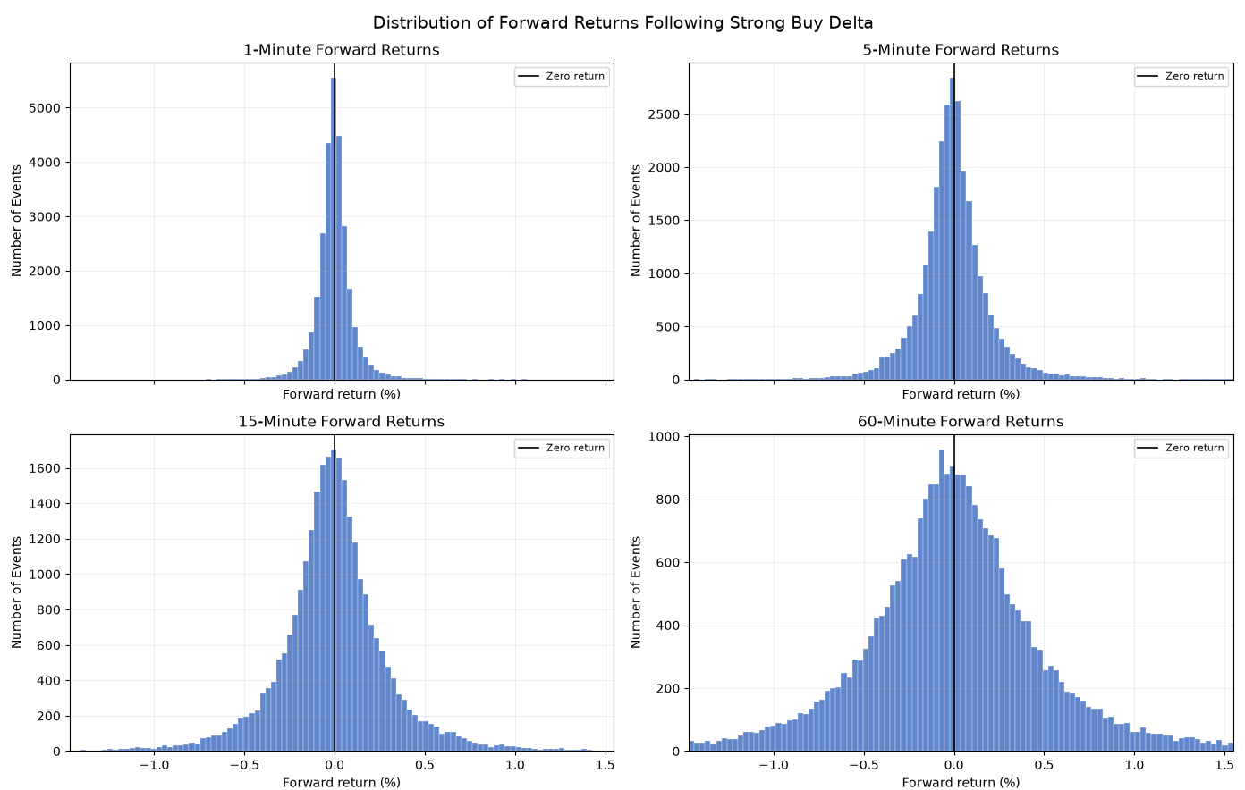
Following a strong raw buy delta, the one-minute distribution is concentrated around zero, but the centre is slightly negative. As the horizon increases, the distribution widens, and the central peak flattens. This widening is confirmed by the standard deviation, which rises from 0.104% at one minute to 0.208%, 0.346% and 0.628% at the subsequent horizons. The mean return remains negative throughout, moving from -0.0017% after one minute to -0.0076% after 60 minutes, while the median moves from -0.0041% to -0.0137%. Positive outcomes account for between 46.8% and 48.6% of observations. The link between the negative mean, negative median and sub-50% positive frequency indicates a small but consistent negative return rather than continuing positive returns.

Histogram 2. Distributions of forward returns following a strong sell delta
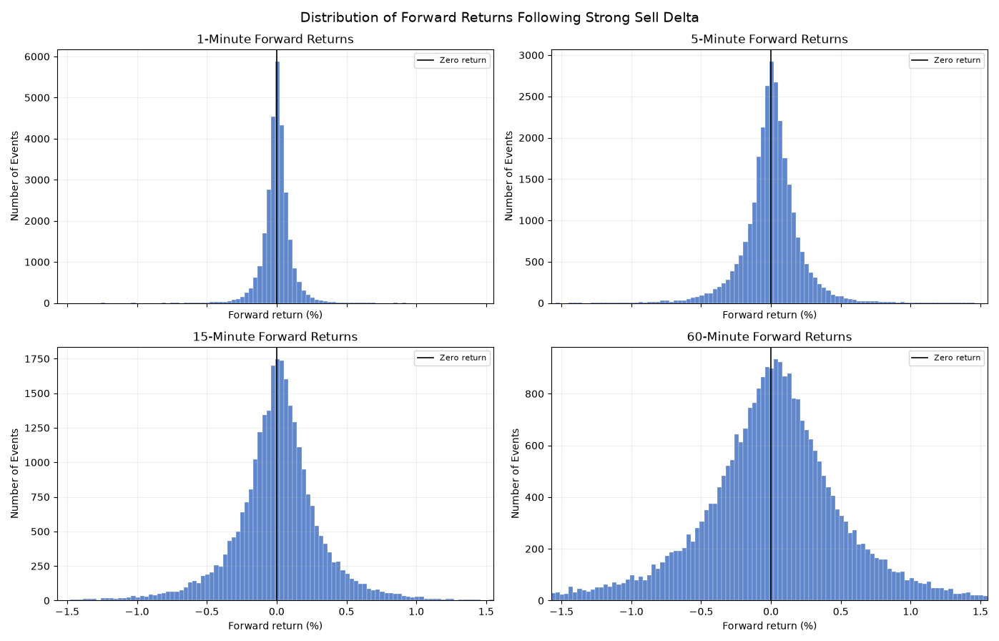
The strong raw sell delta distributions display the opposite directional pattern. Their central mass is positioned slightly to the positive side of zero, especially at the 15- and 60-minute horizons. Mean forward returns increase from 0.0020% at one minute to 0.0038%, 0.0060% and 0.0112%, while the corresponding medians rise from 0.0031% to 0.0076%, 0.0126% and 0.0211%. Between 52.1% and 52.4% of returns are positive. Dispersion again increases along with the horizon, with standard deviation rising from 0.104% to 0.643%. The positive medians and positive returns suggest that the result is not created solely by a few large positive outliers. Visually and numerically, strong aggressive selling is therefore followed by a weak rebound. This reversal appears somewhat clearer than the response following strong buying, although its average size remains very small relative to the dispersion of individual returns.

Histogram 3. Distributions of forward returns following strong normalised buy delta
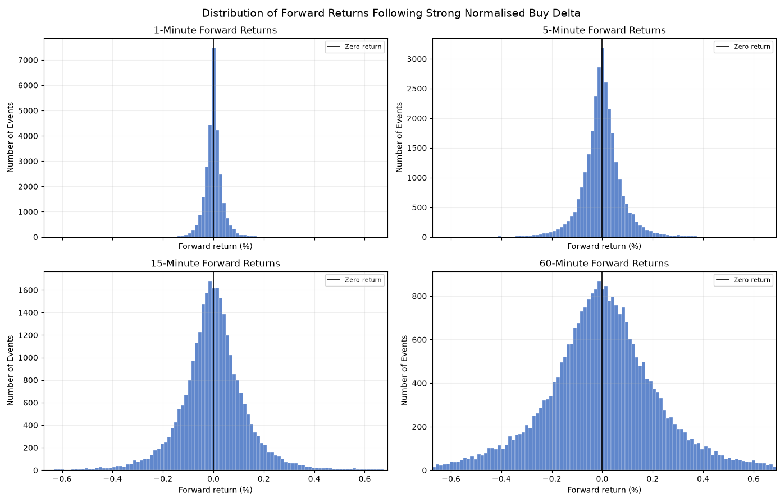
The distributions of the normalised deltas are more narrowly concentrated than those of the raw deltas. Standard deviation rises from only 0.039% at one minute to 0.087%, 0.149% and 0.303% as horizons increase. Despite the widening, the distribution remains centred extremely close to zero. Mean returns are 0.0009%, 0.0007% and 0.0006% over the horizons before switching to negative at the 60-minute mark, as it equals -0.0019%. Median returns are zero or marginally negative, and the positive returns rise from 48.1% to 49.7%. As a result, this data alone does not provide enough evidence that a strong normalised buy delta leads to an increase in subsequent price movement.

Histogram 4. Distributions of forward returns following strong normalised sell delta
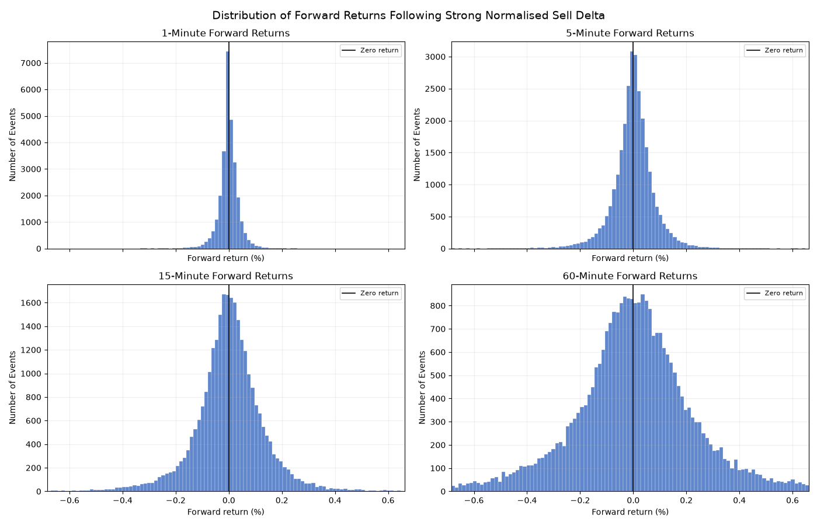
Strong normalised sell delta produces a similarly narrow and near-zero distribution. The one minute mean is -0.0002% and the median is zero. At 5, 15 and 60 minutes the means are small but positive at 0.0015%, 0.0018% and 0.0024%. Positive-return frequencies are close to an even split, reaching 51.3% after 5 minutes and 50.6% at both 15 and 60 minutes. Standard deviation increases from 0.040% to 0.296% across the horizons. These results suggest a very weak short-term rebound following strong normalised sell deltas; however, the magnitude is considerably smaller than that observed for the raw sell delta.
In conclusion, all conditional return distributions are strongly peaked around zero and retain visible tails, so a single average cannot adequately represent the range of possible outcomes. The increasing standard deviation across horizons is much larger than the associated change in mean return. For example, the 60-minute mean after strong raw sell delta is 0.0112%, compared with a standard deviation of 0.643%. Delta therefore provides, at most, a small shift in the conditional distribution rather than a precise forecast of the next return. Second, the directional relationship for raw delta is contrarian: strong buy delta is followed by slightly negative returns, whereas strong sell delta is followed by slightly positive returns. This is consistent with a short-term exhaustion or liquidity-absorption interpretation, under which unusually aggressive market orders encounter passive liquidity and the price partially reverses after the imbalance.

Correlation Analysis
Correlation analysis was conducted to examine whether delta has a consistent relationship with subsequent Bitcoin returns across the complete sample of one-minute intervals. Unlike the percentile analysis, which focuses specifically on strong and very strong delta events, this analysis uses the full range of raw and normalised delta observations.
Pearson correlation measures the linear relationship between delta and forward returns. Spearman's correlation measures whether returns tend to increase or decrease as delta increases, without requiring a linear relationship.
Table 5: Correlation between Delta and Forward Returns
Condition | Minutes Forward | Pearson Correlation | Spearman Correlation
raw delta | 1 | -0.015947 | -0.018497
raw delta | 5 | -0.014963 | -0.021410
raw delta | 15 | -0.012646 | -0.014427
raw delta | 30 | -0.009426 | -0.014317
raw delta | 60 | -0.011101 | -0.012093
normalised delta | 1 | 0.000195 | -0.011492
normalised delta | 5 | -0.005244 | -0.016103
normalised delta | 15 | -0.003758 | -0.010441
normalised delta | 30 | -0.005146 | -0.010513
normalised delta | 60 | -0.005584 | -0.009061

Raw delta produced negative Pearson and Spearman correlations across all forward-return horizons. The negative direction indicates a weak contrarian relationship: intervals containing greater buying pressure were, on average, associated with slightly lower subsequent returns, while greater selling pressure was associated with slightly higher subsequent returns. This is consistent with the earlier descriptive results, in which strong buy-delta events were generally followed by small negative returns and strong sell-delta events by small positive returns.
The strongest raw-delta Pearson correlation was observed at the 1-minute horizon, with a value of −0.015947. The strongest Spearman correlation was −0.021410 at the 5-minute horizon. The coefficients generally decreased over longer horizons, although the pattern was not strictly monotonic. This suggests that any relationship between raw delta and future price movement is concentrated primarily within the shortest periods and does not strengthen as the return horizon increases.
Normalised delta demonstrated an even weaker relationship with subsequent returns. Its Pearson correlations ranged from 0.000195 at one minute to −0.005584 at 60 minutes. The 1-minute coefficient is effectively zero, while the remaining coefficients are negative but economically negligible. The Spearman correlations were also negative at every horizon, with the largest magnitude being −0.016103 at five minutes.
The difference between Pearson and Spearman correlation is particularly noticeable for the 1-minute normalised-delta result. Pearson correlation was approximately zero, whereas Spearman correlation remained slightly negative. This suggests a weak tendency for returns to decline as normalised delta increases, but the relationship is not strongly linear. Nevertheless, both coefficients remain too small to indicate meaningful standalone predictive power.
The stronger correlations produced by raw delta suggest that the absolute quantity of aggressive buying or selling may contain more information than the imbalance expressed as a percentage of total volume. However, this result could also reflect market activity and volatility, since larger absolute delta values are more likely during high-volume periods. Consequently, the difference should not be interpreted as proof that raw delta is inherently superior without controlling for additional market conditions.
Overall, the correlation analysis supports the earlier finding of a weak contrarian relationship between order-flow imbalance and subsequent price movement. However, the very small coefficients indicate that neither raw nor normalised delta provides sufficient standalone predictive power. Delta may therefore be more useful when combined with additional variables such as VWAP, cumulative volume delta, volatility and order-book depth.

Statistical Significance and Hypothesis Testing
H₀ : Extreme bid/ask deltas have no significant relationship with subsequent short-term price returns.
H₁ : Extreme bid/ask deltas have a significant relationship with subsequent short-term price returns.
The hypotheses are non-directional. The alternative hypothesis does not assume that extreme delta must cause continuation. A significant result may represent either:
- Continuation: price moves in the same direction as the initial delta.
- Reversal: price moves against the direction of the initial delta.
The objective is to determine whether returns following extreme delta events differ significantly from returns following non-extreme intervals. If the difference is statistically significant, its sign is then used to determine whether the result indicates continuation or reversal.
Separate regression models were estimated for the 1, 5, 15, 30 and 60-minute forward-return horizons. Each model took the following form:
Forward return = Constant + Buy-event effect + Sell-event effect + Error
The constant represents the expected return following non-extreme intervals. The buy- and sell-event coefficients measure how much the return following an extreme event differs from this non-extreme reference group.
For each coefficient, the individual null hypothesis is:
H₀: Event coefficient = 0
A coefficient of zero would mean that the return following the event does not differ from the non-extreme return. A coefficient significantly above or below zero would provide evidence of a relationship between the event and subsequent returns.
Newey-West standard errors were used because consecutive forward returns are not fully independent. This is particularly important for longer horizons because the return windows overlap. The adjustment also accounts for changing volatility and dependence between observations.
The t-statistic was calculated as:
t-statistic = Estimated coefficient ÷ Newey-West standard error
The initial decision rule was:
Reject H₀ when p-value < 0.05
A positive coefficient means that returns following the event were higher than returns following non-extreme intervals. A negative coefficient means that they were lower. The interpretation also depends on the direction of the original delta event:
Event | Positive | Negative
Buy delta | Continuation | Reversal
Sell delta | Reversal | Continuation

Initial results using the 5% significance level
A total of 40 tests were conducted across raw and normalised delta, strong and very strong classifications, buy and sell events, and five forward-return horizons.
The table presents the 19 coefficients that produced unadjusted p-values below 0.05. These are valid results when each test is considered individually. However, they are not yet the final hypothesis-testing results because conducting 40 tests creates a multiple-testing problem.
Table: Results Significant at the Initial 5% Level
Condition | Minutes Forward | t-statistic | p-value | Direction
strong buy delta | 1 | -2.46743 | 0.01361 | Reversal
strong sell delta | 1 | 3.35324 | 0.00080 | Reversal
strong buy delta | 5 | -2.90447 | 0.00368 | Reversal
strong sell delta | 5 | 2.39232 | 0.01674 | Reversal
strong sell delta | 15 | 2.12466 | 0.03361 | Reversal
strong sell delta | 30 | 2.02431 | 0.04294 | Reversal
very strong sell delta | 1 | 2.34560 | 0.01900 | Reversal
very strong sell delta | 60 | 2.13656 | 0.03263 | Reversal
strong normalised buy delta | 1 | 3.97694 | 0.00007 | Continuation
strong normalised buy delta | 5 | 2.10111 | 0.03563 | Continuation
strong normalised sell delta | 5 | 2.02276 | 0.04310 | Reversal
strong normalised sell delta | 15 | 2.18651 | 0.02878 | Reversal
very strong normalised buy delta | 1 | 4.31711 | 0.00002 | Continuation
very strong normalised sell delta | 1 | -2.47714 | 0.01324 | Continuation
very strong normalised buy delta | 5 | 2.54143 | 0.01104 | Continuation
very strong normalised sell delta | 15 | 2.43441 | 0.01492 | Reversal
very strong normalised sell delta | 30 | 3.36037 | 0.00078 | Reversal
very strong normalised buy delta | 60 | 2.54201 | 0.01102 | Continuation
very strong normalised sell delta | 60 | 2.87488 | 0.00404 | Reversal

A statistically significant positive-delta event may be followed by either a positive return, indicating continuation, or a negative return, indicating reversal. Similarly, a significant negative-delta event may be followed by either continued price decline or a subsequent recovery. The hypothesis test is therefore concerned first with whether a relationship exists and then with the direction of that relationship.
To test the hypotheses, separate indicators were created for extreme positive and negative delta events. Forward returns following these events were compared with returns following non-extreme intervals, which formed the reference group. Separate regressions were estimated for the 1, 5, 15, 30 and 60-minute return horizons.
Newey-West standard errors were used in all regressions to improve the reliability of the results. This is important because return data overlap over time (especially over longer horizons), and financial returns often exhibit changing volatility and patterns of dependence. The coefficient can then be interpreted as the difference in average return (in percentage points) between periods following a delta event and those without such an event.
The initial raw-delta results predominantly indicate reversal. Strong raw-buy events produced negative coefficients at one and five minutes, while strong raw-sell events produced positive coefficients from one to 30 minutes. This means aggressive buying was followed by relatively lower returns and aggressive selling was followed by relatively higher returns.
The initial normalised-delta results were less consistent. Normalised-buy events generally produced positive coefficients, indicating continuation, whereas several normalised-sell events produced positive coefficients, indicating reversal. The results therefore did not identify one common response across both event directions.
At this stage, 19 of the 40 tests would individually lead to rejection of their respective null hypotheses. However, it would be inappropriate to treat all 19 as final significant findings without accounting for the number of tests conducted.

The multiple-testing problem
Using a 5% significance level means that every test has some possibility of producing an apparently significant result even when its true effect is zero. Conducting 40 tests increases the overall probability of obtaining at least one false positive.
The unadjusted p-values in the table remain valid descriptions of each individual regression. The problem arises when all 40 tests are considered together and used to draw conclusions about the project’s overall hypothesis.
The Holm method was therefore used to control for multiple testing. The procedure:
- Arranges the 40 p-values from smallest to largest.
- Applies the strictest significance requirement to the smallest p-value.
- Gradually relaxes the requirement as the remaining p-values are examined.
- Produces an adjusted p-value for every test.
- Retains a result only where its adjusted p-value remains below 0.05.
The final decision rule was therefore:
Reject H₀ after adjustment when Holm-adjusted p-value < 0.05

After applying the Holm correction, only four of the original 19 results remained statistically significant.
Table 2: Results Remaining Significant After Holm Adjustment

Condition | Minutes Forward | Estimate | t-statistic | p-value | 95% CI lower | 95% CI upper | Direction | Adjusted p-value
strong sell delta | 1 | 0.00209 | 3.35324 | 0.00080 | 0.00087 | 0.00331 | Reversal | 0.02958
strong normalised buy delta | 1 | 0.00099 | 3.97694 | 0.00007 | 0.00050 | 0.00149 | Continuation | 0.00272
very strong normalised buy delta | 1 | 0.00187 | 4.31711 | 0.00002 | 0.00102 | 0.00271 | Continuation | 0.00063
very strong normalised sell delta | 30 | 0.00975 | 3.36037 | 0.00078 | 0.00406 | 0.01544 | Reversal | 0.02958

The first significant result was the 1-minute strong raw sell-delta coefficient. Its estimate of 0.002091% means that the return following the event was approximately 0.2091 basis points higher than the return following a non-extreme interval. Because the original event represented aggressive selling, but the subsequent relative return was positive, the result indicates reversal.
The principal strong normalised-delta analysis produced one significant result. Strong normalised-buy events were followed by a 1-minute return approximately 0.000995 percentage points (0.0995 basis points) higher than the non-extreme return. This represents continuation following proportional buying pressure.
The very strong normalised-buy result was also significant at the one-minute level. Its coefficient of 0.001867%, equivalent to 0.1867 basis points, indicates continuation. However, very strong buy events are included within the wider strong-buy classification, so these two findings are related rather than independent pieces of evidence.
The final significant result was a very strong 30-minute normalised-sell coefficient. Its positive estimate of 0.009753%, equivalent to 0.9753 basis points, indicates a reversal following extreme selling pressure.

Hypothesis decision
The Holm-adjusted results lead to rejection of the null hypothesis for four specific condition-horizon combinations:
- Strong raw sell delta at one minute.
- Strong normalised buy delta at one minute.
- Very strong normalised buy delta at one minute.
- Very strong normalised sell delta at 30 minutes.
The null hypothesis cannot be rejected for the remaining 36 tests.
The findings therefore provide limited support for the alternative hypothesis that extreme bid/ask delta has a statistically significant relationship with subsequent short-term price returns. However, the evidence is dependent on the delta measure, event direction, level of extremity and return horizon.
The surviving results contain both continuation and reversal. They do not support a general conclusion that prices consistently continue in the direction of aggressive buying or selling. Instead, the market response appears to vary according to the circumstances of the delta event.

5min Results

The five-minute analysis identified 5,688 strong buy and 5,688 strong sell events using the 5th and 95th percentile thresholds. The more restrictive 1st and 99th percentile thresholds identified 1,138 very strong events in each direction.
5%: -243.729
95%: 231.18039999999993
1%: -647.5611200000001
99%: 621.6342000000002
Normalised 5%: -41.52127097792588
Normalised 95%: 40.570365673008126
Normalised 1%: -57.372321916242406
Normalised 99%: 56.49210770475866

Raw Delta analysis

Mean analysis

Strong raw buy delta was followed by negative mean returns across most horizons. The average return was −0.0052% after one minute, −0.0073% after five minutes and reached its lowest value of −0.0134% after 15 minutes. The negative response then weakened, reaching −0.0018% after 60 minutes.
The response was stronger following very strong buy delta. Mean returns were −0.0148% after one minute, −0.0110% after five minutes and −0.0228% after 15 minutes. Returns remained close to zero between 30 and 60 minutes but were still negative after 240 minutes. This indicates that the largest five-minute concentrations of aggressive buying were generally followed by falling rather than rising prices.
Strong sell delta produced the opposite short-term pattern. Mean returns were positive from 1 to 60 minutes, increasing from 0.0056% after one minute to 0.0094% after 60 minutes.
Very strong sell delta generated a considerably larger response. Mean returns were 0.0179% after one minute, 0.0255% after 15 minutes and 0.0694% after 60 minutes.
Overall, the raw mean results present a contrarian relationship. Strong aggressive buying was generally followed by negative returns, whereas strong aggressive selling was followed by positive short-term returns. The relationship was most pronounced for very strong sell delta.

Table 1 + graph 1: Average future returns following various strengths of five-minute normalised delta (%)

Average movement(%) | Column Labels
Minutes Forward | strong buy delta | strong sell delta | very strong buy delta | very strong sell delta
1 | -0.005197 | 0.005594 | -0.014801 | 0.017894
5 | -0.007314 | 0.000460 | -0.010985 | 0.017610
15 | -0.013429 | 0.005841 | -0.022812 | 0.025538
30 | -0.006238 | 0.008861 | -0.002077 | 0.053828
60 | -0.001776 | 0.009443 | -0.000102 | 0.069412
240 | 0.006030 | -0.020402 | -0.008531 | 0.030161
1440 | -0.146840 | -0.145548 | -0.101526 | -0.002376
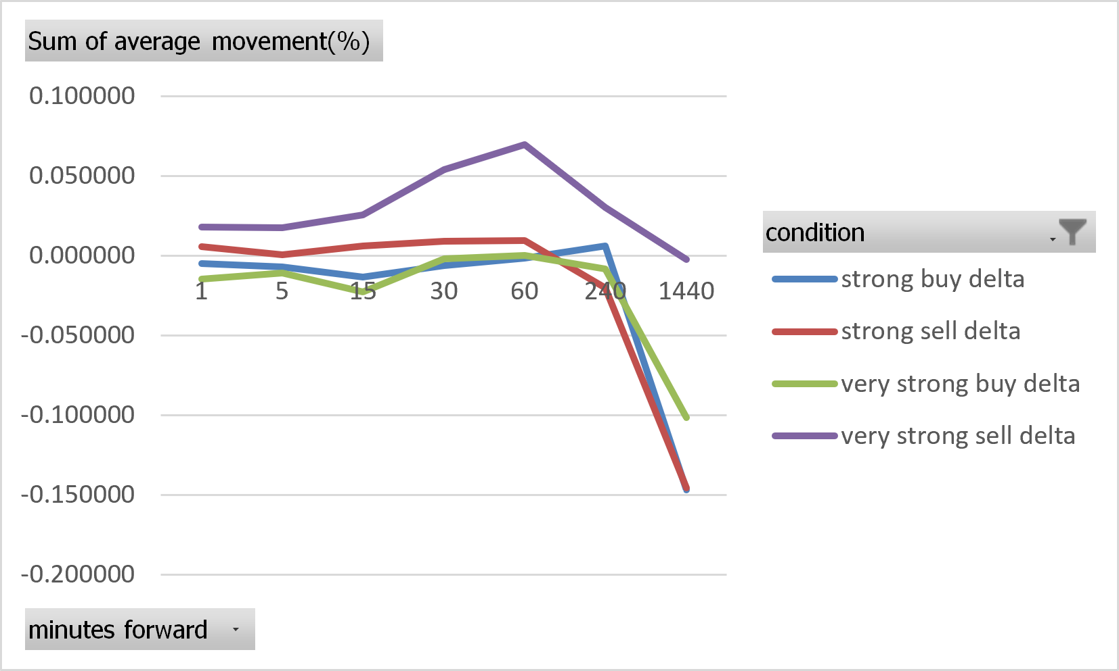

Median analysis

The median results support the pattern found in the means. Strong buy delta produced negative median returns at every horizon. The median declined from −0.0066% after one minute to −0.0230% after 30 minutes and remained negative at −0.0208% after 60 minutes.
Very strong buy delta produced larger negative medians. These reached −0.0489% after 15 minutes, −0.0503% after 60 minutes and −0.0804% after 240 minutes. The consistently negative medians indicate that the negative average returns were not caused solely by a small number of unusually large price decreases.
Strong sell delta produced positive median returns between 1 and 240 minutes. The median increased from 0.0061% after one minute to 0.0328% after 240 minutes. Very strong sell delta generated larger positive medians, including 0.0421% after 15 minutes and 0.0760% after 60 minutes.
Some differences between the mean and median indicate that extreme returns affected the averages. For example, strong sell delta produced a negative mean return of −0.0204% after 240 minutes but a positive median of 0.0328%. The typical return remained positive, but a smaller number of large negative observations pulled the mean below zero.
Table 2 + graph 2: median of future returns following various strengths of five-minute normalised delta (%)

median movement(%)
Minutes Forward | strong buy delta | strong sell delta | very strong buy delta | very strong sell delta
1 | -0.006646 | 0.006070 | -0.012956 | 0.015432
5 | -0.015324 | 0.007503 | -0.027075 | 0.026964
15 | -0.020661 | 0.022209 | -0.048937 | 0.042130
30 | -0.022970 | 0.023133 | -0.040522 | 0.045313
60 | -0.020752 | 0.021075 | -0.050291 | 0.076032
240 | -0.011711 | 0.032804 | -0.080361 | 0.072242
1440 | -0.064245 | -0.057303 | -0.189452 | 0.033725

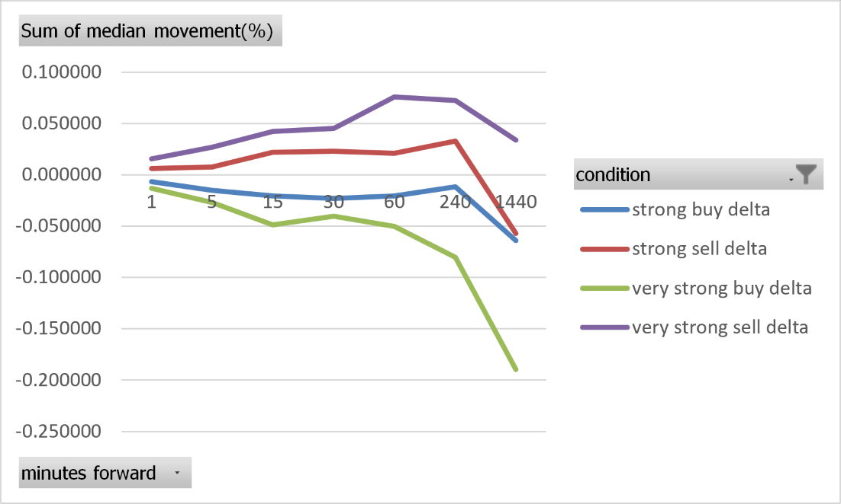

Analysis of Positive return (%)
Only 46.04% of strong buy-delta events were followed by a positive one-minute return. This declined to 45.52% after five minutes before gradually rising to 49.13% after 240 minutes. Positive returns therefore remained below 50% across the short and medium horizons.
The imbalance was stronger following very strong buy delta. Only 42.79% of events produced positive returns after 15 minutes, while the percentage remained below 47% through the 240-minute horizon.
Strong sell delta produced positive-return percentages above 50% from 1 to 240 minutes. The percentage was 53.53% after one minute and reached 54.07% after 15 minutes. Because positive returns following sell delta represent a reversal, these results support the contrarian relationship found in the mean and median.
Very strong sell delta produced the clearest directional imbalance. Positive returns followed 55.98% of observations after one minute, 58.35% after 15 minutes and 56.24% after 60 minutes. The return direction was therefore most consistent following the most extreme sell-delta events.

Table 3 + graph 3: percentage of positive movements following various strengths of five-minute normalised delta (%)

Positive movements (%)
Minutes Forward | strong buy delta | strong sell delta | very strong buy delta | very strong sell delta
1 | 46.04 | 53.53 | 44.90 | 55.98
5 | 45.52 | 52.14 | 44.55 | 55.71
15 | 45.89 | 54.07 | 42.79 | 58.35
30 | 46.96 | 52.67 | 45.08 | 55.98
60 | 47.82 | 52.14 | 46.31 | 56.24
240 | 49.13 | 51.90 | 46.57 | 53.60
1440 | 48.61 | 48.52 | 46.70 | 50.66

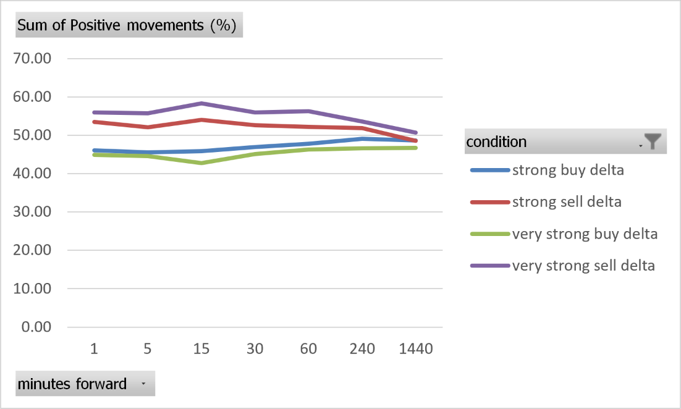

Analysis of Standard Deviation
Standard deviation increased with the forward horizon for every raw-delta condition. Following a strong buy delta, it rose from 0.1072% after one minute to 0.6367% after 60 minutes. Strong sell delta followed a similar pattern, increasing from 0.1128% to 0.6755%.
Very strong delta was associated with greater dispersion. At 60 minutes, standard deviation was 0.7758% following very strong buy delta and 0.8842% following very strong sell delta.
The increase suggests that extreme raw delta occurred during more volatile market conditions. However, the standard deviations were substantially larger than the corresponding mean returns. Individual outcomes therefore varied considerably around the average, meaning raw delta did not produce a uniform price response.

Table 4 + graph 4: Average future returns following various strengths of five-minute normalised delta (%)

standard deviation (%)
Minutes Forward | strong buy delta | strong sell delta | very strong buy delta | very strong sell delta
1 | 0.10718 | 0.11283 | 0.14764 | 0.16035
5 | 0.20403 | 0.25556 | 0.25913 | 0.40494
15 | 0.36590 | 0.39590 | 0.42046 | 0.57889
30 | 0.46013 | 0.52569 | 0.57361 | 0.74080
60 | 0.63672 | 0.67547 | 0.77584 | 0.88425
240 | 1.10956 | 1.16491 | 1.25146 | 1.40606
1440 | 2.45062 | 2.49310 | 2.51436 | 2.80637

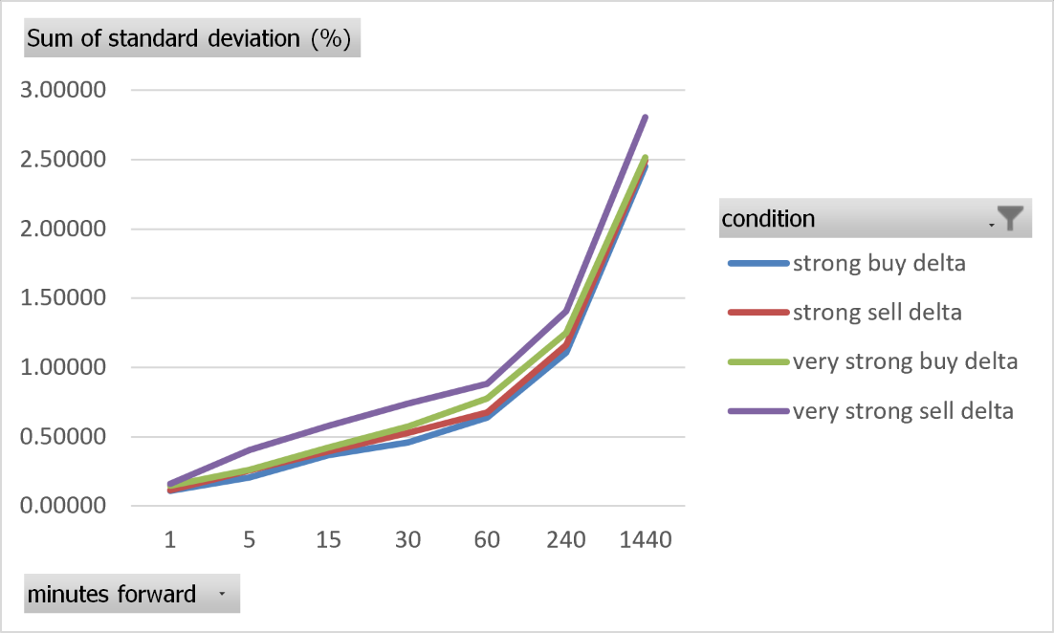

Normalised delta

Analysis of mean returns
The mean returns following normalised delta were substantially smaller than those found using raw delta. Strong normalised buy delta produced mean returns close to zero after one and five minutes. Returns then became slightly negative, reaching −0.0030% after 60 minutes and −0.0026% after 240 minutes.
Strong normalised sell delta also produced returns close to zero at the shortest horizons. The mean became more clearly positive after 30 minutes, reaching 0.0103% after 60 minutes and 0.0084% after 240 minutes.
Very strong normalised buy delta did not produce a consistent short-term response. Mean returns fluctuated around zero before increasing to 0.0195% after 240 minutes. In contrast, very strong normalised sell delta produced positive mean returns at every horizon. These increased from 0.0033% after one minute to 0.0266% after 60 minutes and 0.0436% after 240 minutes.
The normalised mean results therefore retain some evidence of sell-side reversal, particularly following very strong sell delta. Nevertheless, the effects were economically small.
Table 1 + Graph 1: Mean movement (%) returns following various strengths of five-minute normalised deltas

average movement(%)
Minutes Forward | strong buy delta | strong sell delta | very strong buy delta | very strong sell delta
1 | 0.000544 | 0.001467 | -0.000494 | 0.003343
5 | 0.000052 | -0.000077 | 0.000336 | 0.002179
15 | -0.002106 | 0.001138 | -0.001792 | 0.008542
30 | -0.002662 | 0.007214 | 0.000241 | 0.014654
60 | -0.003045 | 0.010265 | 0.000541 | 0.026572
240 | -0.002612 | 0.008423 | 0.019462 | 0.043637
1440 | -0.053575 | -0.032674 | 0.009418 | 0.084114

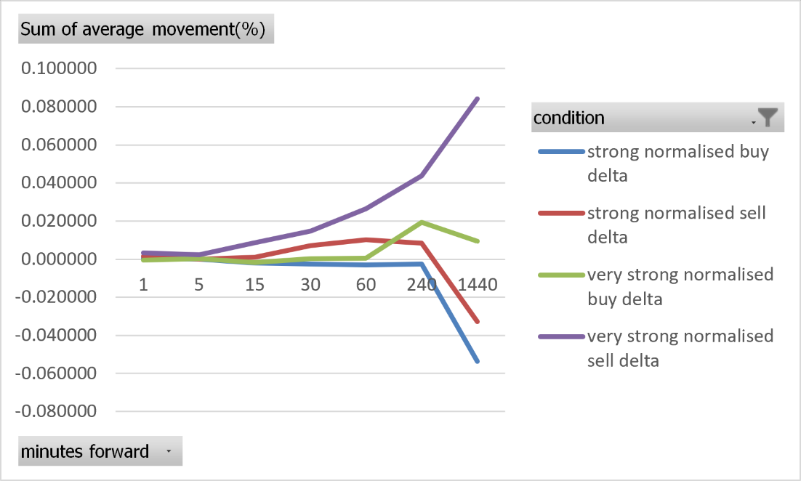

Analysis of Median movement
Strong normalised buy delta produced slightly negative median returns from 1 to 60 minutes. The median declined from approximately zero after one minute to −0.0062% after 60 minutes before becoming slightly positive at 0.0031% after 240 minutes.
Strong normalised sell delta produced positive median returns throughout the analysis. The median increased from approximately zero after one minute to 0.0082% after 60 minutes and 0.0261% after 240 minutes.
Very strong normalised buy delta produced predominantly negative short-term medians, including −0.0067% after 15 minutes and −0.0125% after 60 minutes. The median then became slightly positive at 0.0045% after 240 minutes. Very strong normalised sell delta produced positive medians at every horizon, increasing from 0.0039% after five minutes to 0.0163% after 60 minutes and 0.0447% after 240 minutes.
Consequently, the median results show a clearer directional separation than some of the mean returns. Normalised buy delta was generally followed by slightly negative short-term returns, while normalised sell delta was generally followed by positive returns.
Table 2 + Graph 2: Median movement (%) returns following various strengths of five-minute normalised deltas

median movement (%)
Minutes Forward | strong buy delta | strong sell delta | very strong buy delta | very strong sell delta
1 | -0.000088 | 0.000093 | -0.000086 | 0.000161
5 | -0.001911 | 0.001563 | -0.000294 | 0.003856
15 | -0.004865 | 0.005285 | -0.006701 | 0.008414
30 | -0.005936 | 0.008570 | -0.005076 | 0.013691
60 | -0.006180 | 0.008217 | -0.012499 | 0.016289
240 | 0.003050 | 0.026110 | 0.004478 | 0.044690
1440 | 0.049734 | 0.088628 | 0.057400 | 0.186112

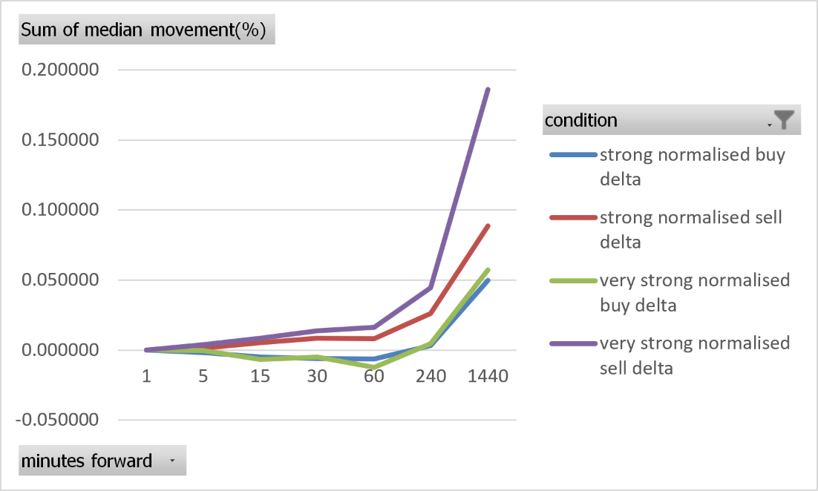

Analysis of positive return(%)
Positive return percentages following a strong normalised buy delta were close to 50%. They ranged from 46.17% after one minute to 50.29% after 240 minutes. This represents a weaker directional imbalance than that observed using raw buy delta.
Strong normalised sell delta produced positive-return percentages ranging from 51.01% to 52.77% between 1 and 240 minutes. The results remained slightly above 50%, but the difference was relatively small.
The very strong conditions produced a larger separation. Only 43.94% of very strong normalised buy-delta events were followed by positive one-minute returns. Very strong normalised sell delta produced positive returns after 52.64% of one-minute observations, increasing to 53.95% after 60 minutes and 55.32% after 240 minutes.
Normalisation therefore reduced the directional imbalance for the broader strong-delta categories. The clearest remaining relationship was again found following very strong sell delta.
Table 3 + Graph 3: percentage of positive movement (%) returns following various strengths of five-minute normalised deltas

Positive movements (%)
Minutes Forward | strong buy delta | Strong sell delta | very strong buy delta | very strong sell delta
1 | 46.17 | 51.01 | 43.94 | 52.64
5 | 48.35 | 51.29 | 48.86 | 53.78
15 | 47.86 | 52.37 | 46.13 | 53.87
30 | 48.29 | 52.69 | 48.42 | 54.92
60 | 48.79 | 51.83 | 47.36 | 53.95
240 | 50.29 | 52.77 | 50.62 | 55.32
1440 | 51.60 | 53.18 | 52.46 | 58.71

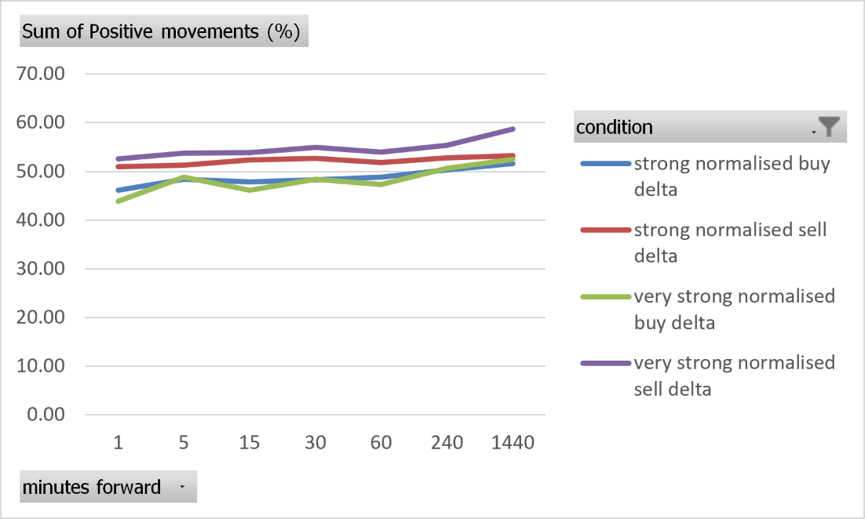

Analysis of Standard Deviation
Normalised-delta returns displayed lower standard deviations than raw-delta returns. For strong normalised buy delta, standard deviation increased from 0.0515% after one minute to 0.3241% after 60 minutes and 0.6811% after 240 minutes. Strong normalised sell delta produced similar values of 0.0473%, 0.3126% and 0.6925%.
Very strong normalised delta did not produce greater short-term dispersion. Standard deviation increased from approximately 0.04% after one minute to 0.2955% following very strong buy delta and 0.2509% following very strong sell delta after 60 minutes. At 240 minutes, the corresponding values were 0.5748% and 0.5728%.
This difference suggests that large raw delta partly identified periods of high market activity and volatility. Dividing delta by total volume reduced this activity effect and isolated the relative imbalance between aggressive buying and selling. However, the variation in returns remained much larger than the corresponding means.
Table 4 + Graph 4: Standard Deviation of returns following various strengths of five-minute normalised deltas

standard deviation (%)
Minutes Forward | strong buy delta | strong sell delta | very strong buy delta | very strong sell delta
1 | 0.05151 | 0.04733 | 0.04035 | 0.03985
5 | 0.09839 | 0.09498 | 0.08672 | 0.08320
15 | 0.15382 | 0.16760 | 0.12153 | 0.12142
30 | 0.22125 | 0.22872 | 0.17499 | 0.17094
60 | 0.32415 | 0.31256 | 0.29554 | 0.25091
240 | 0.68113 | 0.69255 | 0.57481 | 0.57282
1440 | 1.84535 | 1.81494 | 1.68636 | 1.56515
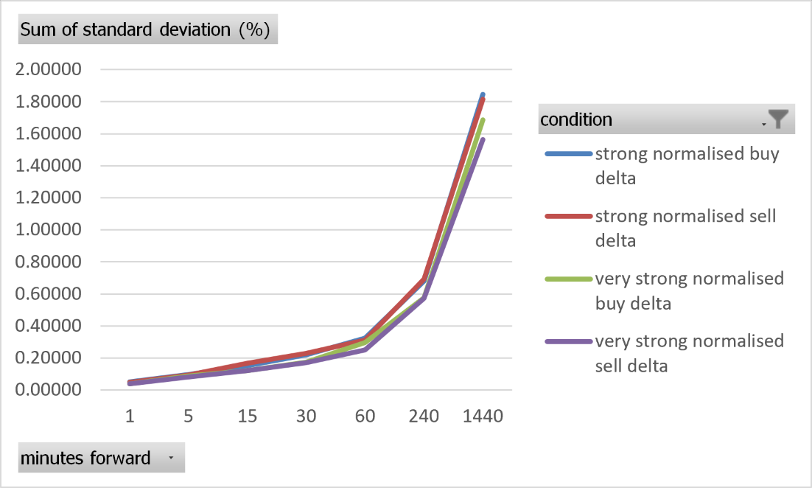

Distributions

Raw delta
The forward-return distributions following strong raw buy and sell delta were sharply concentrated around zero at the one-minute horizon. Most observations produced only a small price movement, while a smaller number of events generated considerably larger positive or negative returns. The high central peaks and extended tails indicate that the distributions were more peaked and heavy-tailed than a normal distribution.
As the forward horizon increased, the distributions became progressively wider. The five-minute distributions remained strongly concentrated around zero, whereas the 15- and 60-minute distributions displayed a much broader range of returns. This is consistent with the increase in standard deviation reported previously, as more time allowed a greater amount of price movement to occur after the signal.
Following strong buy delta, the distributions were centred slightly below zero at the shorter horizons. This is consistent with the negative mean and median returns, although the displacement from zero was small relative to the overall width of each distribution. Positive returns remained common, meaning strong buy delta did not produce a consistent negative response after every event.
The strong sell-delta distributions were positioned slightly more positively, particularly over the 15- and 60-minute horizons. This supports the positive mean, median and positive-return percentages observed following aggressive selling. Nevertheless, the distributions continued to overlap substantially with negative returns, indicating that the sell-side reversal was probabilistic rather than uniform.
The raw distributions also became less sharply peaked at longer horizons but retained relatively long tails. Therefore, extreme positive and negative returns remained more frequent than would be expected under a normal distribution. This supports the use of medians and distributional tests alongside mean returns because the mean may be influenced by a relatively small number of extreme observations.

Histogram 1: Distribution of Strong buy delta
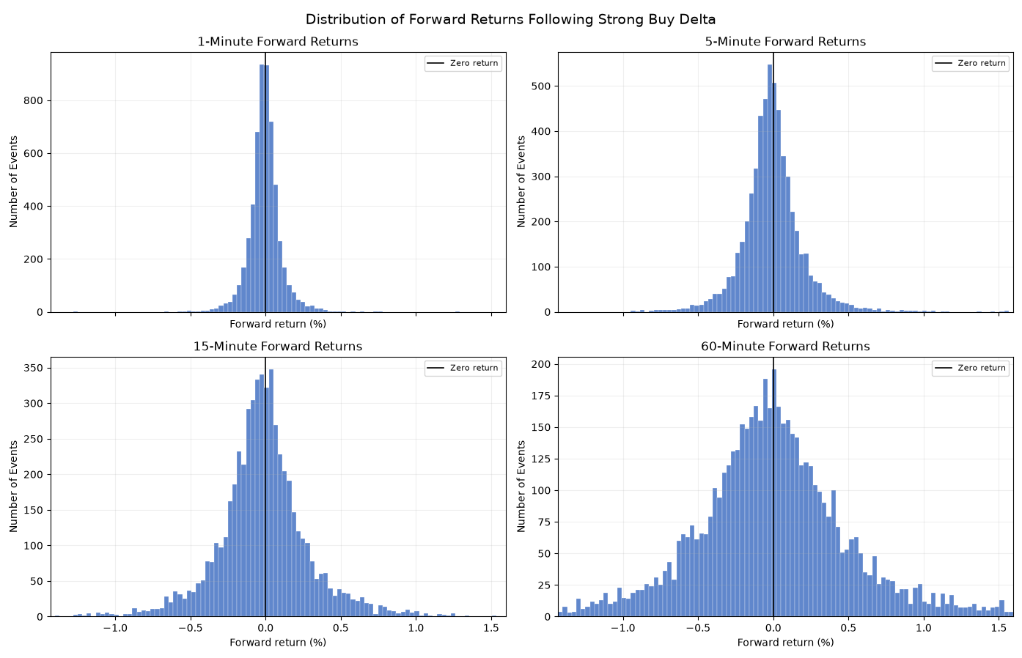
Histogram 2: Distribution of Strong sell delta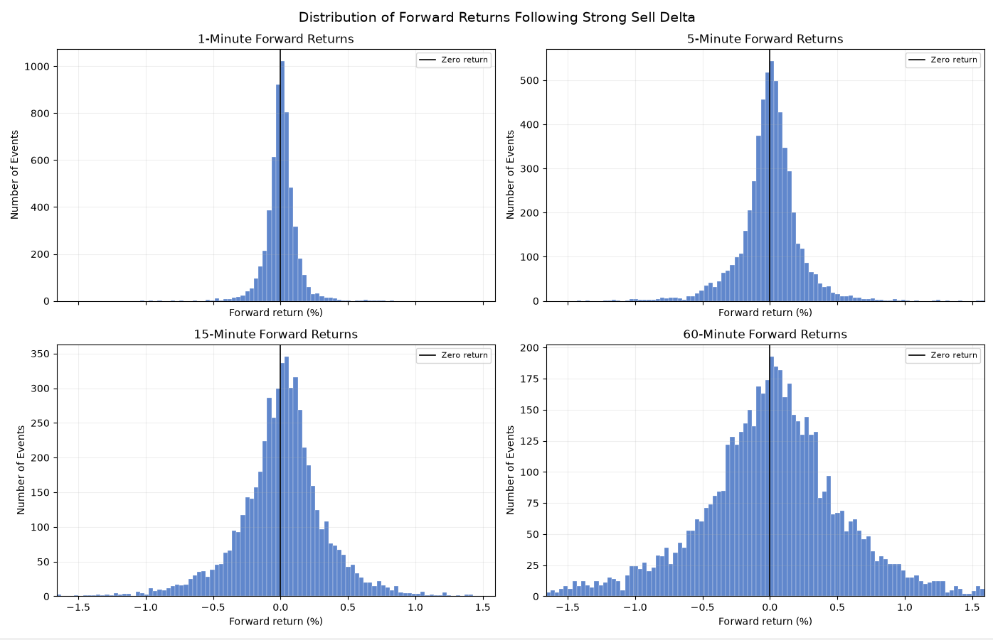

Normalised Delta
The distributions following strong normalised delta were more narrowly concentrated around zero than those selected using raw delta. This was particularly visible at the one- and five-minute horizons, where most observations were grouped within a relatively small return range. The narrower distributions are consistent with the lower standard deviations reported for normalised-delta events.
Strong normalised buy delta produced distributions centred very close to zero, with only a slight negative displacement across the shorter horizons. Although this corresponds with the generally negative short-term medians, the considerable overlap on either side of zero demonstrates that the directional relationship was weak.
Strong normalised sell delta also produced sharply peaked short-term distributions. At the longer horizons, the centre shifted slightly towards positive returns and the right-hand side became more extended. This is consistent with the positive medians and positive-return percentages following normalised sell delta, although the shift remained small relative to the total dispersion.
As with raw delta, the normalised distributions widened considerably between the one- and 60-minute horizons. They also retained high central peaks and visible tails, showing that normalisation did not produce normally distributed forward returns. However, the tails were less extensive than those observed for raw-delta conditions.

Histogram 3: Distribution of Strong Normalised buy delta

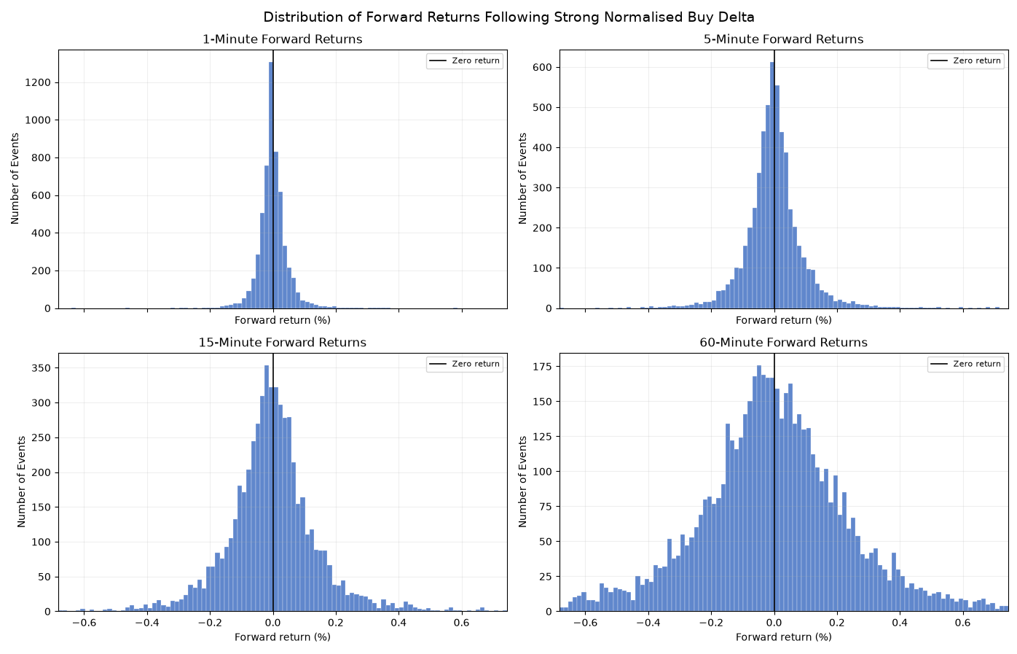
Histogram 4: Distribution of strong Normalised sell delta
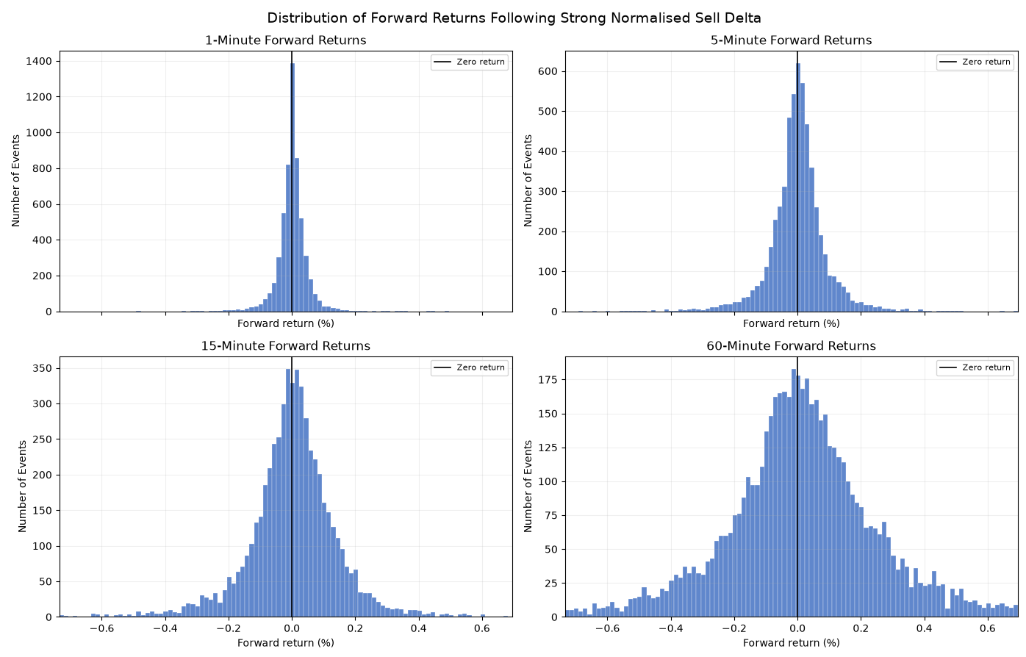
The distributions support the descriptive results but also demonstrate the limited size of the observed relationship. Raw buy-delta events were associated with a slight movement of the return distributions below zero, while raw sell-delta events produced a slight movement above zero. Normalised delta showed the same general direction, but the separation was weaker and the distributions were more tightly concentrated around zero.
In every condition, the shift in the centre of the distribution was small relative to its overall width. Strong delta therefore changed the probability of a positive or negative return rather than determining the direction of the subsequent movement. This explains why the mean and median followed a contrarian pattern while a substantial proportion of individual observations still moved in the opposite direction.
Compared with the previous one-minute signal analysis, the five-minute distributions do not provide evidence of a universally larger effect. The broader strong-delta categories remained highly concentrated around zero under both signal timeframes. The principal difference was concentrated among very strong raw sell-delta events, for which the five-minute signal produced larger positive mean and median returns. The distributional evidence therefore supports a qualified conclusion: aggregating delta over five minutes may improve the identification of extreme sell-side exhaustion, but it does not consistently increase the effect of all strong-delta signals. Formal correlation and hypothesis tests are required to determine whether these apparent differences are statistically significant.

Correlation Analysis
Correlation analysis was used to examine whether the magnitude and direction of five-minute delta were associated with subsequent returns across the full sample.

Condition | Minutes Forward | Pearson Correlation | Spearman Correlation
delta | 1 | -0.044812 | -0.031055
delta | 5 | -0.014118 | -0.022560
delta | 15 | -0.023388 | -0.024357
delta | 30 | -0.016333 | -0.023248
delta | 60 | -0.019014 | -0.018243
normalised delta | 1 | -0.011210 | -0.026750
normalised delta | 5 | -0.003700 | -0.017493
normalised delta | 15 | -0.008040 | -0.020754
normalised delta | 30 | -0.011035 | -0.021655
normalised delta | 60 | -0.009946 | -0.017116

Raw delta had a negative Pearson correlation with returns across all forward horizons. The strongest was −0.0448 for the one-minute return, while the others ranged from −0.0141 to −0.0234. This supports the reversal pattern found earlier: higher positive delta was generally followed by slightly lower returns, while more negative delta was followed by slightly higher returns. However, all correlations were close to zero, indicating a weak relationship.
Normalised delta also had negative Pearson correlations, ranging from −0.0037 to −0.0112. These were weaker than the raw-delta results, suggesting that the absolute amount of trading activity may contribute to the relationship. Even so, neither measure showed a strong linear association with future returns.
The Spearman results were also negative. Raw-delta correlations ranged from −0.0182 to −0.0311, while normalised-delta correlations ranged from −0.0171 to −0.0268. Their similarity to the Pearson results suggests that the negative relationship was not caused only by a few extreme observations. However, the coefficients were still very small and showed no strong ranked relationship.
Compared with the one-minute signal, the five-minute delta generally produced stronger negative correlations. For example, the one-minute forward Pearson correlation for raw delta increased in absolute size from −0.0159 to −0.0448. The five-minute signal also produced more negative correlations at the 15-, 30- and 60-minute horizons, although the results at the five-minute horizon were similar. Raw-delta Spearman correlations were also more negative for the five-minute signal at every horizon.
Overall, the five-minute delta showed a slightly clearer reversal relationship than the one-minute delta. Aggregating order flow over five minutes may therefore capture buying or selling exhaustion more effectively. However, every correlation remained below 0.05, indicating that the improvement was small and that delta had little ability to predict subsequent returns on its own. The hypothesis tests will determine whether these relationships are statistically significant.

Statistical Significance and Hypothesis Testing

H₀: Extreme bid/ask delta has no statistically significant relationship with subsequent short-term price returns.
H₁: Extreme bid/ask delta has a statistically significant relationship with subsequent short-term price returns.

5min Hypothesis Test
Before adjustment, 15 of the 40 tests were significant at the 5% level. All 15 indicated reversal rather than continuation.
For strong raw delta, buy and sell signals were significant at the one-minute horizon. Strong buy delta produced an estimated return of −0.0051%, while strong sell delta produced an estimate of 0.0057%. Strong buy delta was also significant after 5 and 15 minutes, although these results did not remain significant after adjustment.
Very strong raw buy and sell delta were significant after one minute, with estimates of −0.0147% and 0.0180%. Very strong sell delta was also significant after 30 and 60 minutes, producing larger estimates of 0.0569% and 0.0752%.
Normalised-delta results were mainly concentrated on the sell side. Strong normalised sell delta was significant after 1, 30 and 60 minutes. Very strong normalised sell delta was significant after 1, 15, 30 and 60 minutes. No strong or very strong normalised buy-delta result was significant.
These unadjusted results support the earlier descriptive findings, particularly the tendency for aggressive selling to be followed by positive returns.
After Hom adjustment:
Condition | Minutes Forward | Estimate (%) | Direction | Adjusted p-value | Significant at 5% | Significant after adjustment
strong buy delta | 1 | -0.00510681 | Reversal | 0.013472875 | TRUE | TRUE
strong sell delta | 1 | 0.00568411 | Reversal | 0.006165769 | TRUE | TRUE
very strong buy delta | 1 | -0.01470692 | Reversal | 0.028181951 | TRUE | TRUE
very strong sell delta | 1 | 0.01798882 | Reversal | 0.006036808 | TRUE | TRUE
very strong normalised sell delta | 60 | 0.03196694 | Reversal | 0.00548511 | TRUE | TRUE

Four of the five surviving results occurred at the one-minute forward horizon and involved raw delta. Their confidence intervals did not cross zero, providing evidence of an immediate reversal following both aggressive buying and aggressive selling.
For example, the estimated effect following very strong raw sell delta was 0.0180%, with a 95% confidence interval from 0.0087% to 0.0273%. Very strong raw buy delta produced the opposite response, −0.0147%, with a confidence interval of −0.0233% to −0.0061%.
The only normalised-delta result that remained significant was a very strong sell delta after 60 minutes. This yielded an estimate of 0.0320% with a confidence interval of 0.0155% to 0.0484%. The very strong normalised sell result after 30 minutes narrowly failed the adjusted threshold, with an adjusted p-value of 0.0507.
The null hypothesis can be rejected for the five conditions that remained significant after adjustment. All five results indicate reversal: strong buying was followed by negative returns, while strong selling was followed by positive returns.
However, the null hypothesis cannot be rejected across delta conditions generally. Most of the tests were not significant after adjustment, and the surviving estimates were small. The evidence is therefore concentrated in immediate raw-delta reversals and the longer 60-minute response following very strong normalised selling.

Overall, the five-minute signal provides evidence that extreme delta can be related to subsequent returns, particularly when aggressive buying or selling is measured using raw delta. The results also support the earlier indication that extreme sell delta produces the clearest reversal response.
Although the five-minute estimates were generally larger than those found in the descriptive one-minute analysis, separate significance tests do not prove that the five-minute signal has a significantly larger effect. A direct comparison between the two signal timeframes would be needed to establish this.

15min Hypothesis Test
The 15-minute sample contained approximately 37,918 observations, falling slightly at longer forward horizons because of missing end-of-sample returns. Around 1,896 observations qualified in each strong-delta tail, while approximately 380 qualified in each very strong tail.
Before adjustment, five of the 40 tests were significant at the 5% level:

strong buy delta | 15 | -0.0183357 | 0.017869191 | Reversal | 0.714768
very strong sell delta | 60 | 0.08658011 | 0.03990368 | Reversal | 1
strong normalised buy delta | 1 | -0.00310463 | 0.021889227 | Reversal | 0.85368
strong normalised sell delta | 30 | 0.01228655 | 0.029259947 | Reversal | 1
strong normalised sell delta | 60 | 0.01992299 | 0.022563039 | Reversal | 0.857395
All five results indicated reversal. However, none remained significant after the Holm adjustment. The null hypothesis, therefore, cannot be rejected for the 15-minute signal timeframe.
Overall, the 15-minute results follow the same general reversal pattern as the shorter signal timeframes, but the evidence is less reliable. The smaller number of observations and qualifying events also produced wider standard errors. Therefore, the 15-minute signal does not provide robust additional evidence beyond the one- and five-minute results.

Economic results
In this section, we will test whether the following results, which reject the null hypothesis, are economically viable if an algorithm were to enter at the close and exit at the allotted time. This is to test if the strength of the delta alone can lead to monetary gains. This will be tested by investing £100 each time a valid candle appears and will be treated as a real trade on Binance, so it will be subject to fees. No leverage will be assumed, and no liquidation parameters will be in place. The fees on Binance are 0.1% maker and 0.1% taker
1 min results:
Condition | Minutes Forward | Position | Trades | Gross Return (%) | Net profit (%) | Profitable trades after fees
strong sell delta | 1 | Long | 28,429 | 56.34 | -5631.52 | 731
strong normalised buy delta | 1 | Long | 28,429 | 24.65 | -5663.38 | 56
very strong normalised buy delta | 1 | Long | 5688 | 10.1 | -1127.5 | 7
very strong normalised sell delta | 30 | Long | 5688 | 40.31 | -1097.33 | 425

All conditions produced a positive gross profit, proving that without trading fees, it can be profitable to follow these conditions and make money. However, if we look at net income, all of them come back negative with the strong normalised buy delta coming back with the worst results, with a total net profit of -5563%, with strong sell delta following close behind with -5631% and very strong normalised buy delta with -1127.5%, all following the 1-minute time frame, so buying and holding for 1 min before selling.
Very strong normalised sell delta on a 30-minute interval produced the second-highest gross profit of 40.31%, but the highest net profit of -1097%. This is still negative; therefore, none of the statistically valid one-minute signals was economically profitable under the assumed fees. Next, we test if the statistically accepted 5-minute results are viable.
5 min results:
Condition | Minutes Forward | Position | trades | Gross return (%) | Net return (%) | Profitable trades after fees
strong buy delta | 1 | short | 5688 | 29.56 | -1108 | 183
strong sell delta | 1 | long | 5688 | 31.81 | -1105 | 191
very strong buy delta | 1 | short | 1138 | 16.84 | -210.74 | 79
very strong sell delta | 1 | long | 1138 | 20.36 | -207.26 | 99
very strong normalised sell delta | 60 | long | 1138 | 30.24 | -197.4 | 188

All five trading conditions produced positive gross returns before fees. Strong sell delta generated the highest gross return among the one-minute holding periods at 31.81%, compared with 29.56% following strong buy delta. The sell-side condition also produced slightly more profitable trades after fees, with 191 compared with 183.
A similar pattern appeared for very strong raw delta. A very strong sell delta generated a gross return of 20.36%, while a very strong buy delta generated 16.84%. The sell condition recorded 99 profitable trades after fees, compared with 79 for the buy condition. This supports the earlier finding that extreme selling produced a clearer reversal than extreme buying.
The strongest result after fees came from a very strong normalised sell delta held for 60 minutes. It generated a gross return of 30.24%, the least negative net return of −197.40%, and 188 profitable trades from a smaller sample of 1,138 events. The longer holding period, therefore, captured more of the upward reversal following extreme normalised selling.
Despite positive gross returns in every condition, all strategies produced substantially negative net returns after fees. The five-minute signals therefore showed some ability to identify the direction of subsequent price movement, particularly after extreme selling, but the movements were not large enough to overcome transaction costs. As a result, none of the tested conditions was economically profitable as standalone trading strategies.

Conclusion
This study examined whether extreme bid/ask delta in the Binance BTCUSDT perpetual futures market contained information about subsequent short-term price movements. Overall, the results show that extreme delta had a statistically significant relationship with future returns, but this relationship was weak and depended on the signal timeframe, delta measure and forward horizon.
The descriptive results generally showed a pattern of reversal. Strong positive delta was often followed by slightly negative returns, while strong negative delta was followed by slightly positive returns. This relationship was clearest following very strong sell delta, suggesting that intense aggressive selling may represent short-term exhaustion or absorption by passive buyers. However, the return distributions remained centred close to zero, and their standard deviations were substantially larger than the mean effects.
The correlation analysis reached a similar conclusion. Correlations between delta and subsequent returns were consistently weak, with every coefficient below 0.05 in absolute value. The five-minute signal generally produced more negative correlations than the one-minute signal, indicating a slightly clearer reversal relationship. Nevertheless, delta had very little ability to explain future returns on its own.
After adjustment, the one-minute analysis retained a mixture of reversal and continuation results. Strong sell delta and very strong normalised sell delta indicated reversal, while strong and very strong normalised buy delta indicated continuation. The five-minute results were more consistent: the valid raw buy and sell conditions reversed after 1 minute, while the very strong normalised sell delta reversed after 60 minutes. No 15-minute signal remained significant after adjustment.
The five-minute timeframe therefore produced the clearest overall evidence of short-term reversal, particularly following extreme sell delta. Aggregating order flow over five minutes may capture sustained buying or selling pressure more effectively than a single one-minute observation. However, the five-minute effect was not larger under every condition, so it cannot be concluded that five-minute delta was universally more informative.
The economic analysis showed that statistical significance did not translate into profitability. All valid one- and five-minute conditions generated positive gross returns in the expected trading direction. However, every condition produced a negative net return once the assumed maker and taker fees were included. The very strong normalised sell-delta signal held for 60 minutes produced the strongest five-minute result, but it was still unable to overcome transaction costs.
The null hypothesis can therefore be rejected only for specific delta conditions and horizons, rather than for extreme delta generally. Extreme bid/ask delta contains limited information about subsequent BTCUSDT returns, with the strongest evidence pointing towards sell-side exhaustion and short-term reversal. However, the effects are small, inconsistent across conditions and not economically profitable as standalone trading strategies.

Robustness
The initial analysis examined whether an unusually strong bid–ask delta was associated with subsequent Bitcoin returns. Although the results identified several statistically significant relationships, these effects may depend on the wider market conditions in which the delta event occurs. Adding additional parameters can reveal a strong imbalance when the price is trading at different levels relative to its recent value.
The same forward horizons will also be used: 1, 5, 15, 30, and 60 minutes. For every combination of delta condition, forward period and any new conditions, the analysis reports the number of observations, mean forward return, t-statistic, p-value, Confidence Interval and the previous adjusted p-value after multiple testing using the Hom method. With statistical significance evaluated at the original threshold of 5%. A result is accepted as statistically significant if p < 0.05.

Volume Weighted Average Price
To assess this possibility, the analysis is extended by conditioning each extreme delta event relative to its position and distance to the Volume Weighted Average Price (VWAP). VWAP is the average traded price weighted by trading volume over a set period, usually a calendar day starting at 00:00 UTC. It provides an approximate measure of an asset's price and fair value on a trading day.
The VWAP conditions will be broken into 3 test types:
- Position – Below or Above
- Distance – Very far, far, medium, close, very close
- Position and Distance
VWAP distance = ((close – VWAP) / VWAP) x100, the absolute value (using .abs) being utilised to sort the format into % so that each condition could be allocated percentile ranges in increments of 20%, with very close being 0-20% and close being 20-40% and so on.
680 tests were conducted over various Delta, VWAP and forward period conditions.
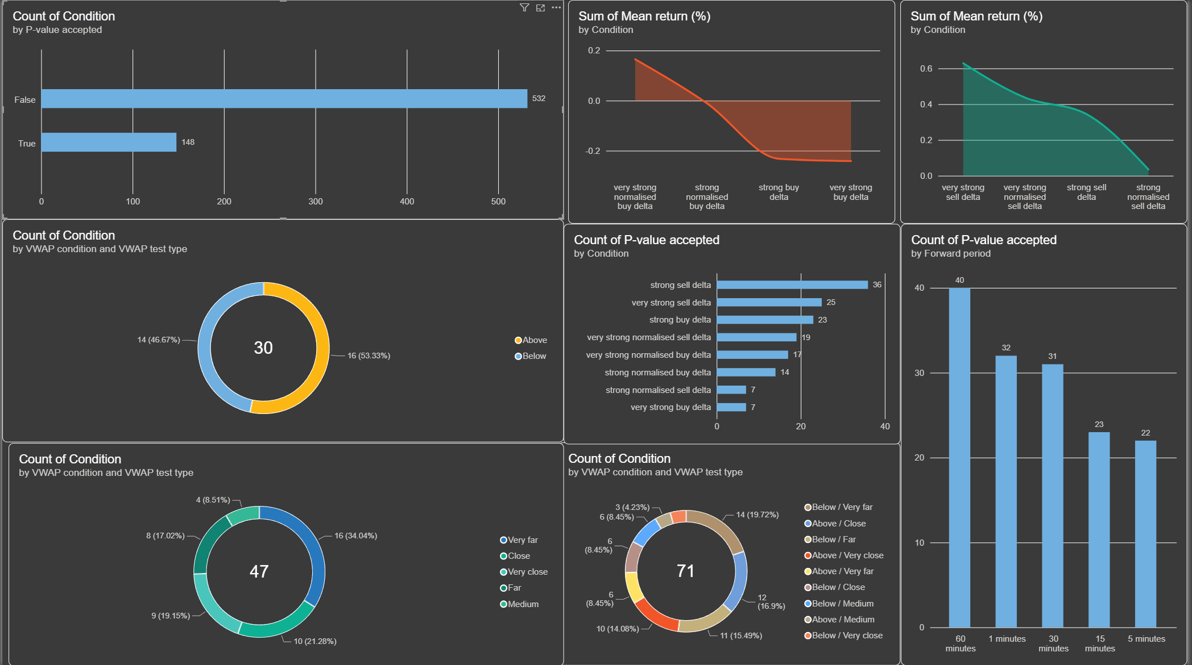
Of the 680 VWAP-conditioned hypothesis tests, 148 produced an unadjusted p-value below 0.05, while 532 were not statistically significant. Therefore, 21.76% of the tested combinations rejected the null hypothesis of a zero mean forward return. This demonstrates that statistical significance was not present across most VWAP conditions, but a meaningful concentration of significant results remained after the original observations were separated according to their position and distance from VWAP.
Significance was most frequent over the 60-minute horizon, which produced 40 accepted results, followed by one minute with 32 and 30 minutes with 31. VWAP position alone was relatively balanced, with 16 significant results above VWAP and 14 below it. However, VWAP distance showed a clearer difference: the very-far category produced 16 accepted results, compared with only four for the medium-distance category. The most common combined condition was below and very far from VWAP, with 14 significant results.
The mean-return charts also show a clear directional difference between buy- and sell-delta events. Accepted raw sell-delta conditions were associated with positive returns, with very strong sell delta producing the largest combined mean return, followed by strong sell delta. In contrast, strong and very strong raw buy delta produced negative combined mean returns. This supports the reversal pattern identified previously: aggressive selling was generally followed by price increases, while aggressive buying was followed by price decreases.
After Holm adjustment:
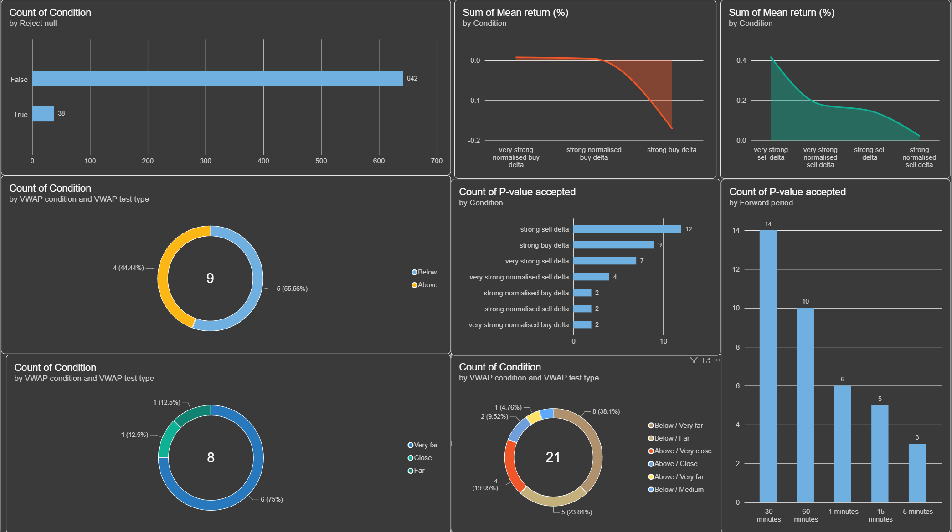
After the p-value adjustment, the number of statistically significant VWAP conditions fell from 148 to 38, representing a reduction of approximately 74%. Strong sell delta retained the greatest number of significant results, with 12, followed by strong buy delta with 9 and very strong sell delta with 7. The 30-minute period produced the most accepted results, with 14, followed by 60 minutes with 10, while 6 remained significant over the 1-minute period.
Importantly, these six one-minute results corresponded directly with the three conditions accepted in the original one-minute hypothesis test. Strong sell delta remained significantly below VWAP and very far below VWAP, with positive returns in both cases, supporting the original reversal finding. Strong normalised buy delta remained significant when close to VWAP and above/close to VWAP, while very strong normalised buy delta remained significant below VWAP and at a below/medium distance. These normalised-buy conditions also retained positive returns, consistent with the continuation identified in the original test.
Therefore, all three original one-minute findings survived the adjustment within at least two VWAP environments and maintained their original direction. This provides evidence that the original relationships were robust, although their significance was conditional on VWAP locations rather than consistent across the entire market.

Cumulative Volume Delta
The second robustness test examined whether the relationship between strong delta and subsequent returns depended on the direction of cumulative volume delta (CVD). CVD was calculated by cumulatively summing candle-level delta and resetting the calculation every seven days:
CVD = CVD^{(t-1)} + Delta^{t}
Observations were classified as positive CVD when cumulative buying volume exceeded cumulative selling volume and negative CVD when cumulative selling volume exceeded cumulative buying volume.
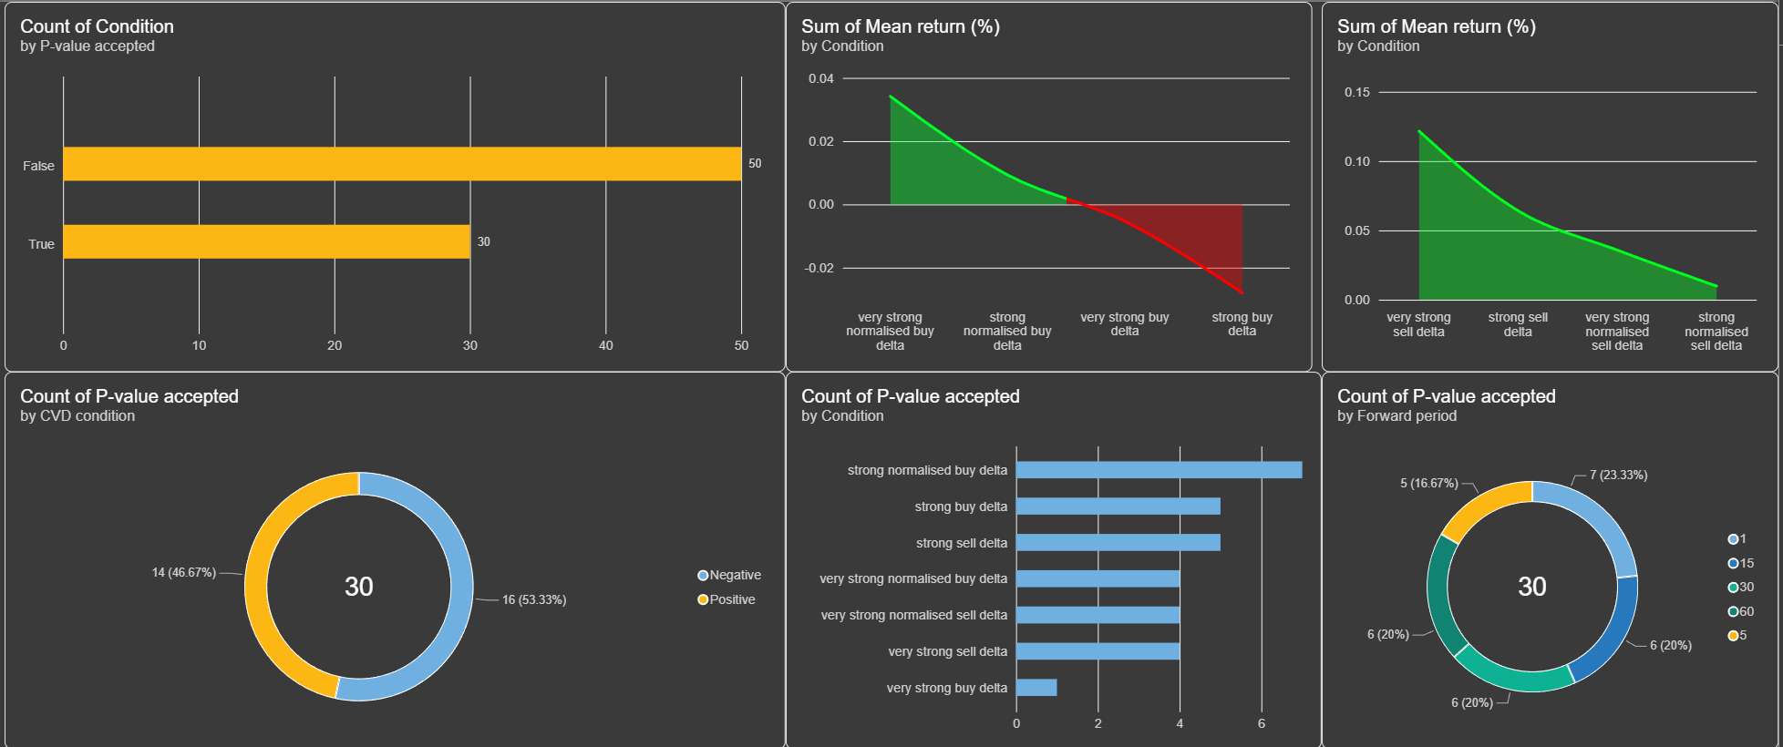
Using the raw p-value, 30 of the 80 tested combinations were statistically significant, representing 37.5% of the results. Significant findings were almost evenly divided between negative CVD with 16 and positive CVD with 14. Strong normalised buy delta produced the most accepted results with seven, while strong buy and strong sell delta each produced five. The results were also reasonably distributed across the return periods, although the one-minute horizon produced the highest number with seven.
The direction of the mean returns continued to show reversal for raw delta. Significant sell-delta conditions generally produced positive returns, while strong buy delta produced negative returns. Normalised buy-delta conditions instead produced positive returns, indicating continuation. Although the charts sum returns across several tests and should only be interpreted directionally, this pattern is consistent with the original analysis.
Importantly, all three findings accepted in the original one-minute hypothesis test remained significant when CVD was negative. Strong sell delta retained a positive mean return, supporting reversal, while strong normalised buy delta and very strong normalised buy delta retained positive mean returns, supporting continuation. The raw CVD results therefore provide initial evidence that the original one-minute relationships were robust, but primarily during periods of negative seven-day CVD.
After Holm adjustment:

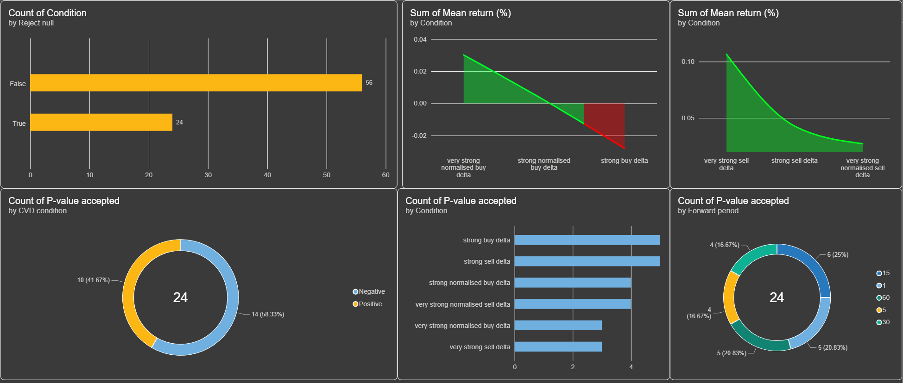
Following the p-value adjustment, 24 of the 80 CVD-conditioned tests remained statistically significant, compared with 30 using the raw p-value. Negative CVD produced 14 accepted results and positive CVD produced 10, indicating that significant relationships were slightly more concentrated when seven-day cumulative selling exceeded cumulative buying. Strong buy and strong sell delta produced the most accepted results, with five each.
The significant mean returns continued to support reversal for raw delta. Strong sell-delta events were followed by positive returns, whereas strong buy-delta events produced negative returns. Very strong sell delta generated the largest positive combined mean return. The normalised results were less consistent, although very strong normalised buy delta continued to produce positive returns.
Most importantly, the original one-minute findings remained significant after both CVD conditioning and p-value adjustment. Strong sell delta, strong normalised buy delta and very strong normalised buy delta all retained positive one-minute returns when CVD was negative. Therefore, the CVD test supports the robustness of the original findings, while also showing that their statistical strength was concentrated within a negative seven-day CVD environment.

Conclusion
Overall, the robustness tests provide qualified rather than universal support for the original finding that unusually strong selling pressure is followed by positive returns. The VWAP analysis showed that the reversal effect was particularly evident when strong sell delta occurred under more extreme market conditions. When price was very far from VWAP, the relationship was initially significant across all forward periods, although only the 30-minute and 60-minute results remained significant after adjusting for multiple testing. Strong sell delta recorded above VWAP also remained significant at selected horizons. These findings suggest that the predictive value of sell delta depends partly on the position and distance of price relative to VWAP, with the clearest evidence appearing over longer forward periods.
The CVD test provided a further assessment of whether the original results remained present after accounting for the broader direction of cumulative order flow. Although some combinations produced significant raw p-values, the adjusted results were more limited. This demonstrates that several apparently significant relationships may have occurred because many conditions and forward periods were tested. Therefore, the isolated unadjusted findings should not be treated as strong evidence unless they also survived the multiple-testing adjustment.
Taken together, the robustness analysis does not show that delta consistently predicts returns under every market condition. Instead, it indicates that the previously observed reversal following strong sell delta is conditional and is most reliable in particular VWAP and CVD environments. The results therefore strengthen the interpretation that order-flow imbalance should not be used as a standalone trading signal. Its usefulness appears to depend on wider market context, while the reduced number of significant adjusted results also supports a cautious interpretation of the original findings.

Limitations

First, transaction costs substantially affected the economic value of the results. The backtest applied a 0.1% maker/ 0.1% taker fee, which was the fee quoted by the Binance exchange. This is relevant because most of the conditions generated a positive gross return before fees were deducted, which then led to a massive decrease of up to -5000% after fees, across anywhere from 28,000 to 5,688 trades. This is important because cheaper fees are available depending on the account tier on Binance, which can change based on trading volume, with the highest tier offering fees as low as 0.011% taker and 0.023% maker, leading to an overall reduction of 83% in fees. Additionally, other exchanges like MEXC have in the past offered 0 fees on BTC futures, which would make the gross profit equal to the net profit, making these conditions economically viable.
Secondly, the study has limited breadth. It examined only BTCUSDT perpetual futures on Binance, focusing primarily on one-minute and five-minute delta signals. The findings cannot automatically be generalised to other cryptocurrencies, traditional financial markets, or longer timeframes. Market liquidity, participant behaviour and order-flow dynamics may differ substantially across these environments. Testing additional assets and exchanges would help determine whether the reversal effect is a broader market phenomenon or specific to Bitcoin.
Relatedly, the dataset represents activity from a single trading venue. Binance order flow does not capture transactions occurring on other cryptocurrency exchanges or in the Bitcoin spot market. A large transaction classified as aggressive buying or selling on Binance may therefore represent only one part of a wider position executed across several venues. Consequently, the calculated delta and CVD measure Binance-specific order flow rather than total market-wide buying and selling pressure.
The historical period covered by the dataset also limits the reliability of the conclusions. Cryptocurrency markets can move between trending, ranging, highly volatile and relatively inactive conditions. Results obtained during one sample period may not remain stable under different market regimes. Although the VWAP and CVD tests introduced additional market context, they do not fully demonstrate that the relationships would persist in future or out-of-sample data.
The statistical analysis also involved testing numerous conditions and forward periods. This increases the probability of identifying significant results by chance. Adjusting the p-values reduced this risk, but it also showed that many relationships which appeared significant initially were not robust after correction. The remaining findings should therefore be treated as evidence of conditional relationships rather than proof of a stable predictive rule.
In addition, forward-return periods frequently overlapped. For example, consecutive delta signals could both include some of the same future price movements. This means that observations were not always completely independent and that multiple positions could theoretically be open simultaneously. The economic backtest did not fully model capital constraints, position overlap or the practical difficulty of executing every signal. Its results should consequently be viewed as an assessment of signal performance rather than a complete trading simulation.
Finally, the study identifies associations rather than causation. A positive return following strong selling pressure does not prove that the sell delta caused the subsequent reversal. Both variables may have been influenced by omitted factors such as volatility, liquidations, funding rates, news events or movements across other exchanges. The findings therefore demonstrate how returns behaved after selected order-flow conditions, but they cannot establish the precise mechanism responsible for those movements.

9. Conclusion
This study examined whether extreme bid/ask delta has a subsequent effect on subsequent short-term price movements using BTCUSDT perpetual futures sourced from Binance. Executed trades were aggregated into one-minute and five-minute intervals, with raw and normalised delta gauged into two extremes: strong, data in the 95th or 5th percentile, and very strong, including deltas in the 99th or 1st percentile, to identify different extremes of buying and selling pressure.
The descriptive results generally supported a reversal effect. A strong positive delta was often followed by negative average returns, whereas a strong negative delta was followed by positive returns. This pattern was most noticeable after very strong sell delta and across longer forward periods. However, the correlations between delta and future returns remained close to zero, showing that delta explained very little of the overall variation in price movements.
Some conditions produced statistically significant results, particularly within the one-minute analysis. Nevertheless, significance was inconsistent across signal types and forward periods, while many relationships disappeared after adjusting for multiple testing. The VWAP and CVD robustness tests similarly showed that the effect depended on the surrounding market environment rather than being present under every condition.
The economic backtest further weakened the practical value of the findings. Although several strategies generated positive gross returns, the individual price movements were generally too small to cover the accumulated entry and exit fees. Every tested strategy therefore produced a net loss under the assumed transaction costs. Extreme delta could not be considered a profitable standalone trading signal.
Overall, extreme bid/ask delta appears to contain a small amount of predictive information, with the evidence generally favouring short-term reversal rather than continuation. However, the relationship is weak, conditional and economically insufficient after fees. These findings are limited by the use of one asset. Future research could test additional markets and periods while incorporating order-book depth, volatility, funding costs and other market conditions.

Biography
Alexander, C., & Heck, D. F. (2020). Price discovery in Bitcoin: The impact of unregulated markets. Journal of Financial Stability, 50(50), 100776. https://doi.org/10.1016/j.jfs.2020.100776
Anastasopoulos, A., Gradojevic, N., Liu, F., Maynard, A., & Tsiakas, I. (2026). Order flow and cryptocurrency returns. Journal of Financial Markets, 79, 101047. https://doi.org/10.1016/j.finmar.2026.101047
Baur, D. G., & Dimpfl, T. (2019). Price discovery in bitcoin spot or futures? Journal of Futures Markets, 39(7), 803–817. https://doi.org/10.1002/fut.22004
Binanace USD-M Aggregate Trade. https://developers.binance.com/en/docs/catalog/core-trading-derivatives-trading-usd-s-m-futures/api/ws-streams/market.
“Binance (Futures) Statistics: Markets, Trading Volume & Trust Score | CoinGecko.” CoinGecko, 2026, https://www.coingecko.com/en/exchanges/binance_futures.
Binance Depth Stream. https://developers.binance.com/en/docs/catalog/core-trading-derivatives-trading-usd-s-m-futures/api/ws-streams/public.
Cheng, Z., Deng, J., Wang, T., & Yu, M. (2021). Liquidation, leverage and optimal margin in bitcoin futures markets. In arXiv.org. https://arxiv.org/abs/2102.04591
Cont, R., Kukanov, A., & Stoikov, S. (2013). The price impact of order book events. Journal of Financial Econometrics, 12(1), 47–88. https://doi.org/10.1093/jjfinec/nbt003
Tools, L. (2026). Loris Tools. Loris Tools. Loris.Tools. https://loris.tools/volume?range=all

